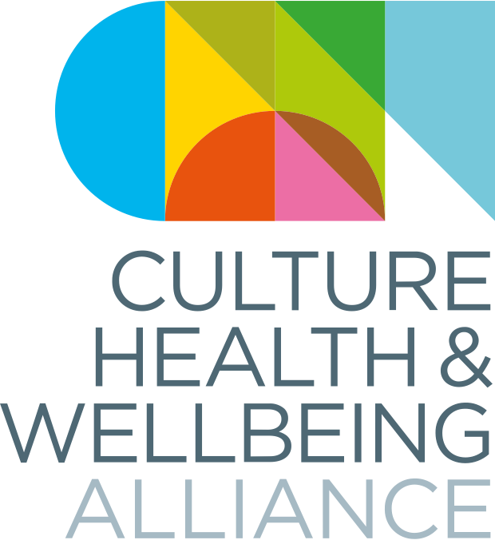

Making Change National Conference
11 – 13 October 2023
The Culture, Health & Wellbeing Alliance

Visual Story

Welcome!

Welcome to Making Change: The Culture, Health & Wellbeing Alliance national conference in Barnsley. This pack contains pictures and information to help you find your way around.

If you have travelled by train, you will arrive at the main station, Barnsley interchange.

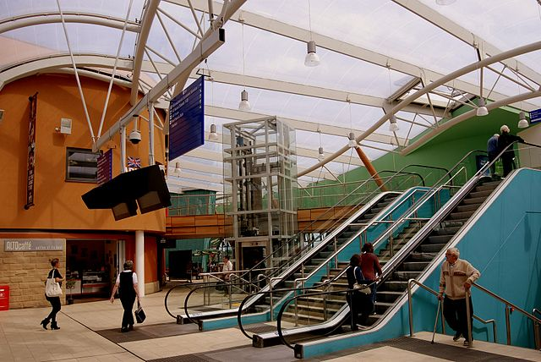

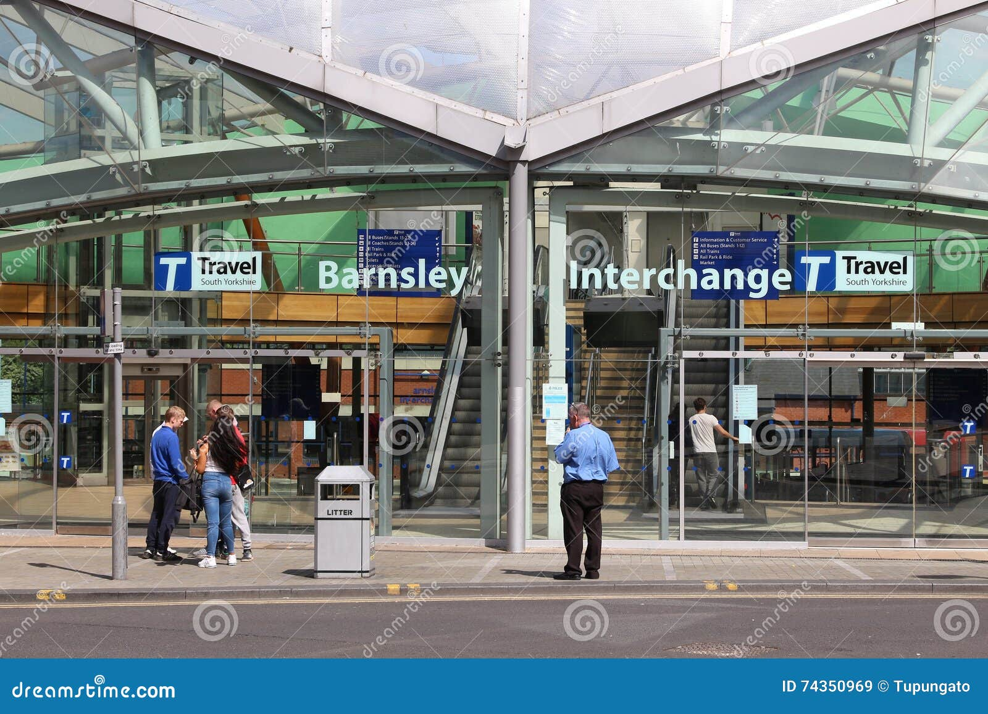

Both our host venues are just a few minutes away.

On Wednesday and Thursday, we will be based at The Civic. On Friday, we will be based at Parkway Cinema.

Here is a video which shows you the route to The Civic from Barnsley Interchange.

Here is a video which shows you the route from the nearest car park.

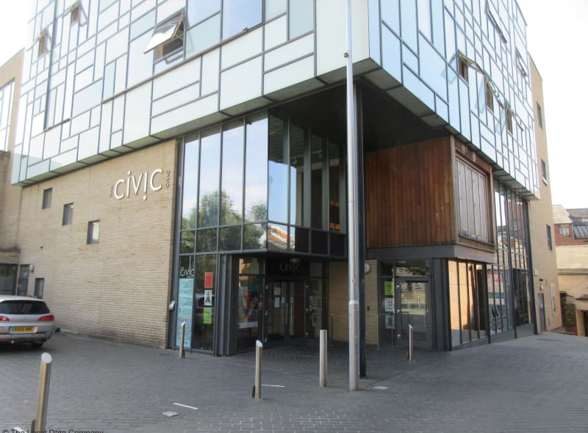

If you come out of Barnsley interchange station and look right, you should see Parkway Cinema, opposite Age Concern.

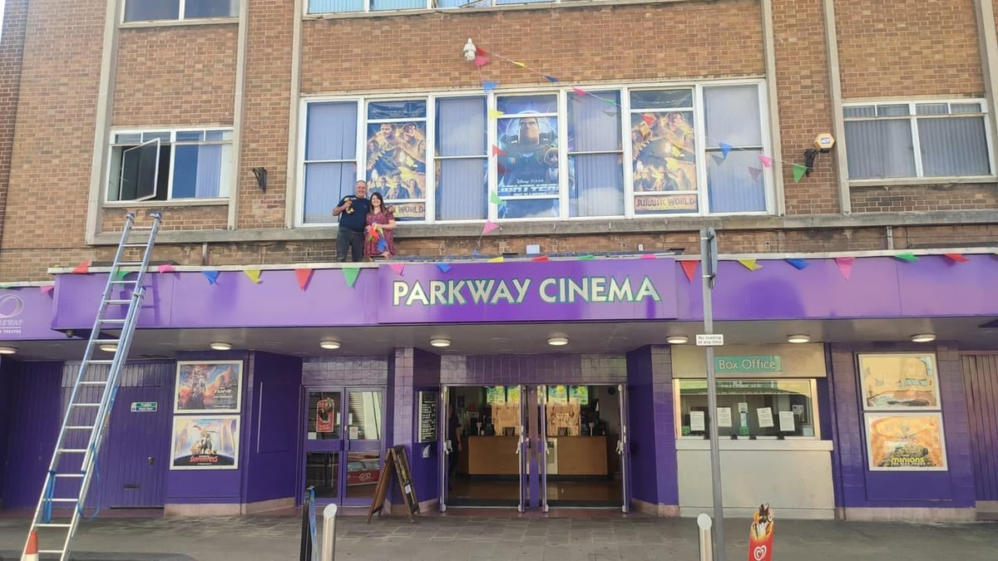

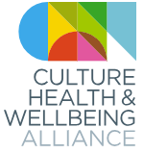
One of our team will be at Barnsley Interchange on each day to direct you.
They will be wearing a t-shirt with this logo.

When you get to the Civic, please enter through the front doors. From there, you can take the stairs or the lift to the Panorama on the first floor.

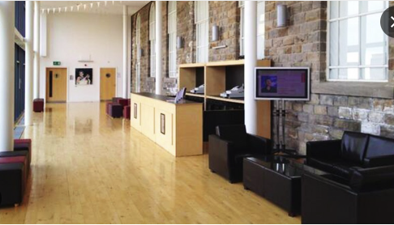

This is where you will sign in with a member of the CHWA team, and where food and refreshments will be served during the breaks. There are also accessible toilets on this level.

Main panels and some breakouts will happen in the Assembly Room.

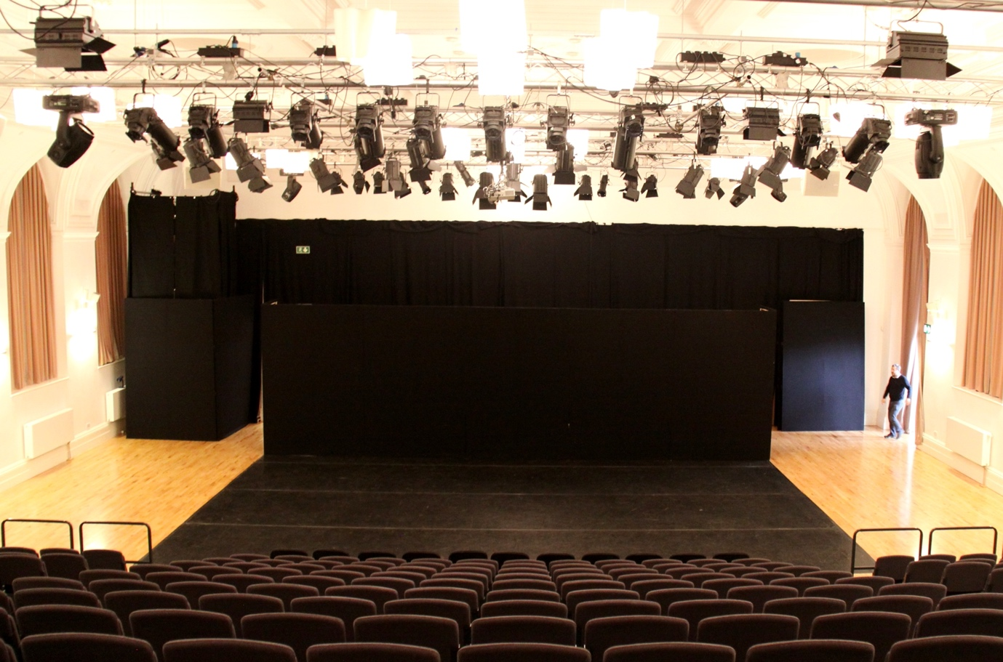

Doors will remain open – please feel free to take comfort breaks as you need to.

If you feel overwhelmed or need to just some time out, there is also a quiet space and prayer room just off the Panorama available to all attendees at all times.

There are three other rooms in Barnsley Civic which we are using for breakout spaces.

Room 305 – First Floor

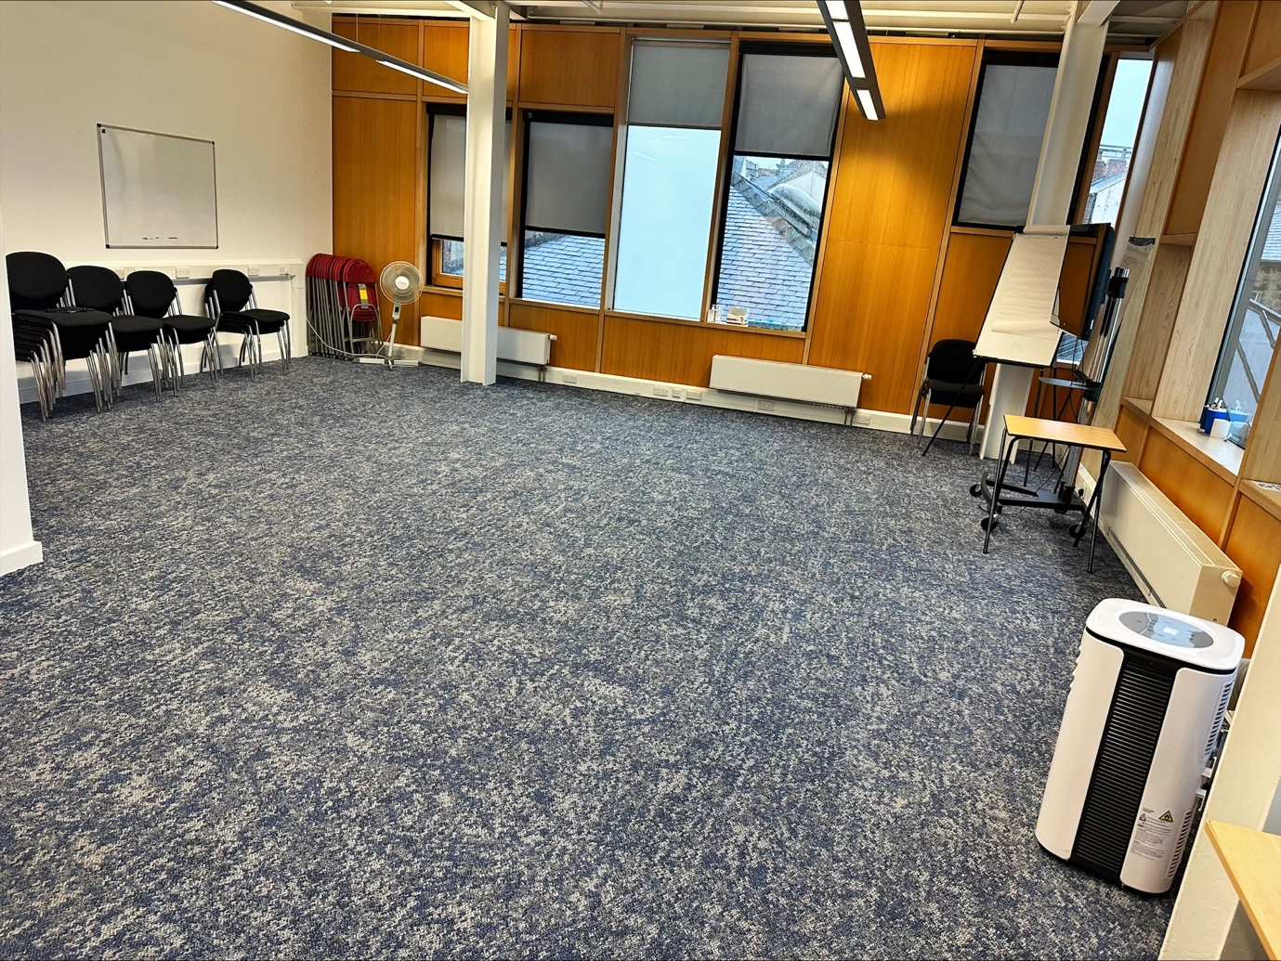

Creation Room – First Floor
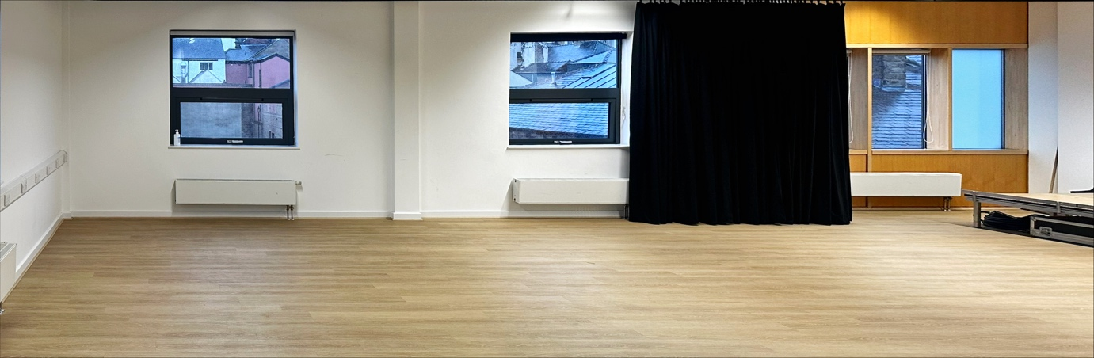

Hanson Room – Ground Floor
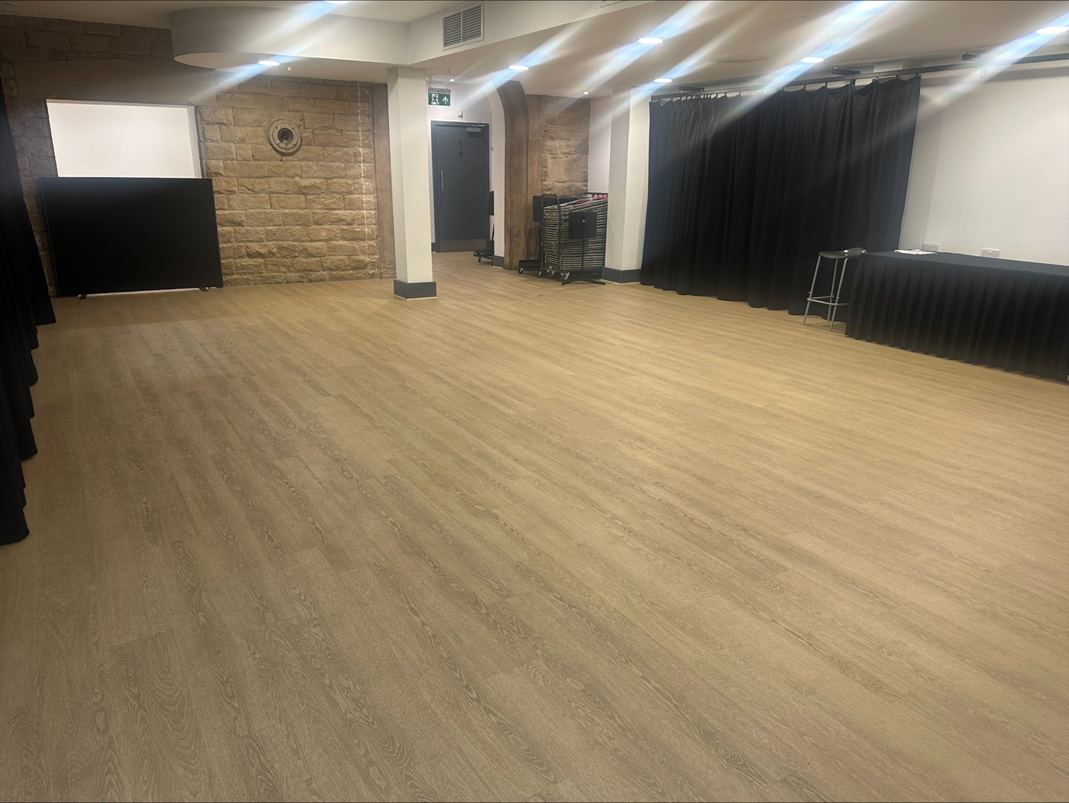

Breakouts are also being held at Digital Media Centre, Cooper Art Gallery, Lightbox @the Library and Barnsley Town Hall.

All these venues are just a few minutes’ walk from the main venue.

The Digital Media Centre looks like this:

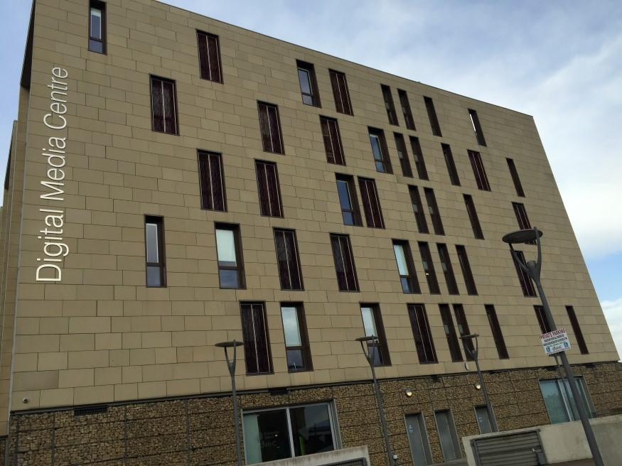

The CHWA team will be able to direct you in between venues. There are also google map routes at the end of this guide.
Inside, we have booked the Murray room, which looks like this:

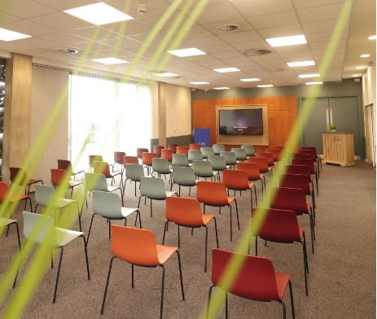

The Hub, which looks like this:

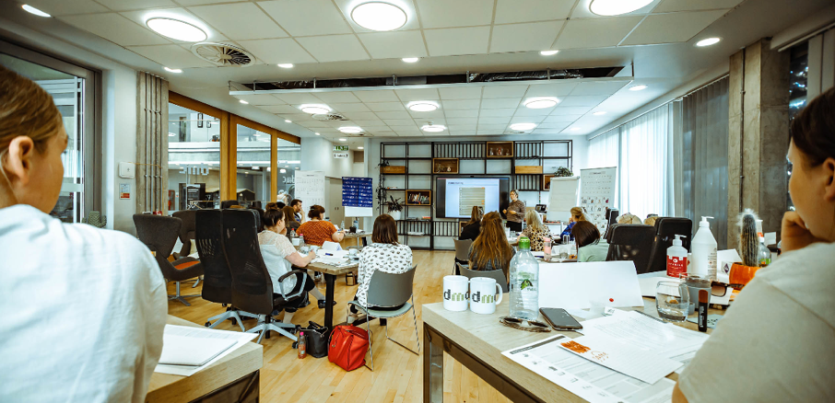
The Walker Room, which looks like this:
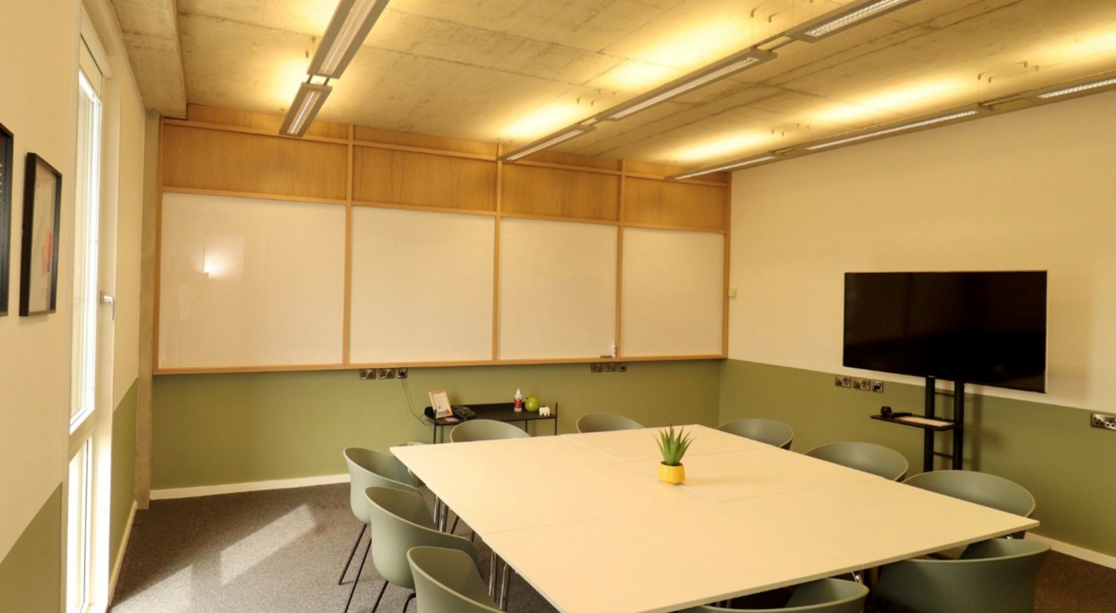

And the Bramah Room, which looks like this:
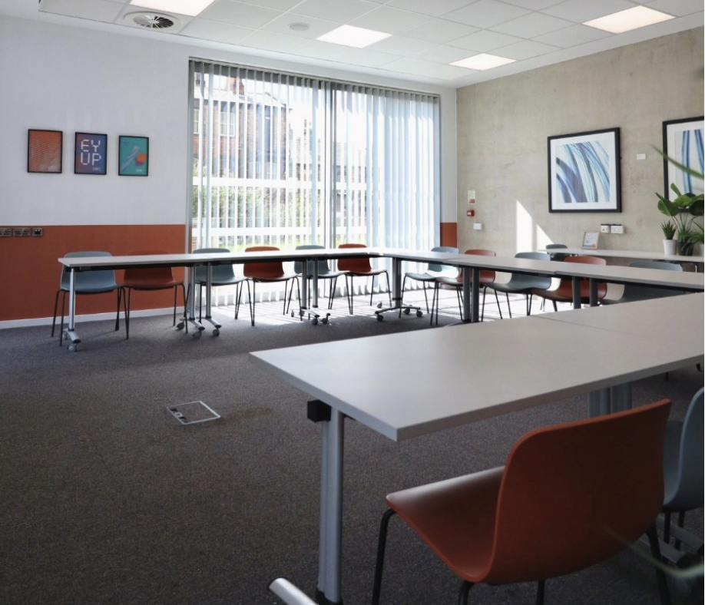

The SPILL workshop, run by Creative Recovery, will take place at the Prospect Street Community Centre.

In the evening, we will be based at Barnsley Town Hall (Weds) and Barnsley Library (Thurs):

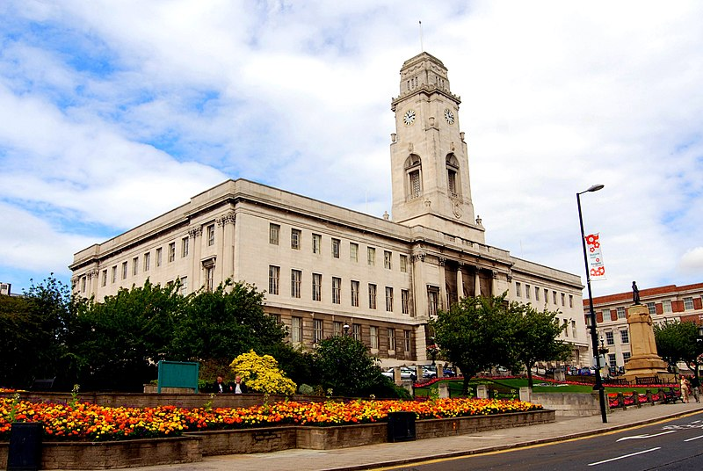

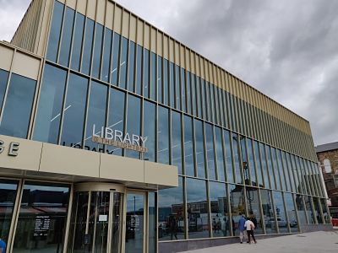

Breakout sessions have been divided by activity type to help you decide what is right for you. You will see a speech bubble describing the activity type.
MAKE
LISTEN

DO
WATCH

THINK

TALK

MEET OUR STAFF
Our team of staff and volunteers will be on hand to help you throughout the conference. Volunteers will be wearing blue TShirts with the CHWA logo – Do speak to them if there’s anything you need.
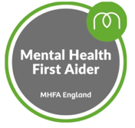
Victoria Hume Fiona Moon
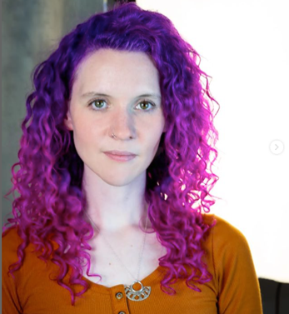
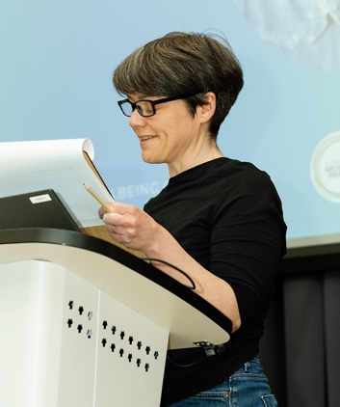

Kheyla Anderson Rachel Howfield Massey
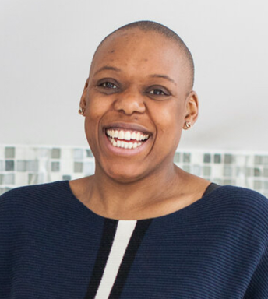
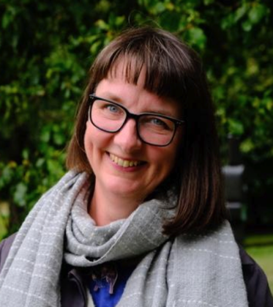

DIRECTIONS AND ACCESS GUIDES

Here are directions and access guides to the venues:

- Barnsley Civic: Hanson St, Barnsley S70 2HZ – Access Guide here
Google Map Directions

- Parkway Cinema: 62 Eldon St, Barnsley S70 2JL – Access Guide here
Google Map Directions
- Digital Media Centre: County Way, Barnsley, S70 2JW - Access Guide here
Google Map Directions

- Lightbox @ The Library: The Glass Works, Barnsley, S70 1GW - Access Guide Here
Google Map Directions

- The Cooper Art Gallery: Church Street, Barnsley, S70 2AH – Access Guide Here
Google Map Directions

- Barnsley Town Hall: Church Street, Barnsley, S70 2TA - Access Guide Here
Google Map Directions

- Experience Barnsley Museum – Inside Barnsley Town Hall Access Guide Here
Google Map Directions

- Creative Recovery, Prospect Street Community Centre, Barnsley, S70 2NR
Access Guide Here
Google Map Directions

