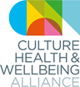 CHWA 2020 AWARDS
We are excited to announce our first ever annual awards for the CHWA 2020 Conference, taking place in Derby on 19-20th March 2020. Working with our award partners, we aim to showcase good practice and people who are leading the way in creating a culture of care for each other, their communities and the world.

Climate Award in partnership with the Happy Museum Project and Culture Declares Emergency
We are joining forces with the Happy Museum Project and Culture Declares Emergency to celebrate the culture, health and wellbeing sector’s progressive work to address climate change and inspire future action. This award aims to recognise the innovation and impact of a project or programme that is leading by example in caring for people, place and planet and responding to the threat of environmental and ecological emergency. Drawing on principles from the Happy Museum Project and the Culture Declares Emergency movement, we are looking to hear from projects/organisations that are recognising the connection between climate, health and creativity/culture. Submissions could include projects that link mental health, climate justice and creativity, for example - or challenge air pollution in a cultural setting. They might be about building “safe and brave places”, grassroots movements or internal campaigns that are raising awareness, or organisations instigating systemic changes in approaches to procurement, commissioning and selection of work and resources.

Confirmed Judges: Hilary Jennings (Happy Museum) and Tony Butler (Derby Museums)

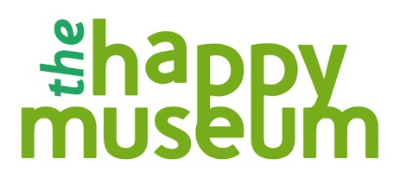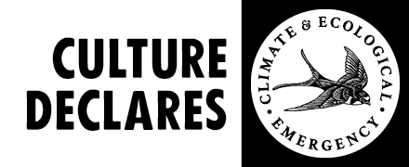

Notes for Applicants:
- Projects or programmes need to be based in the UK and to have taken place in the last two years.
- Projects or programmes can be ongoing but need to be able to demonstrate impact or change.
- Shortlisted applicants will receive discounted ticket rates. If tickets are purchased prior to announcement, money will be reimbursed.
- There will be four shortlisted projects and one winner for each of the three awards.
- The awards are an opportunity to showcase your work nationally. We will be promoting and celebrating all shortlisted nominations and winners in the CHWA Bulletin (February and March 2020) and the shortlisted entries will be published on our website and via our social media channels.

Important Dates for Applicants:
Submission deadline is 5pm, Monday 24th February 2020. Please email this form to info@culturehealthandwellbeing.org.uk
Shortlisted applicants will be contacted by the Alliance soon after and their projects published on the CHWA website.
Winners will be announced at the evening event of the CHWA 2020 Conference: A Culture of Care on Thursday 19 March 2020 and further promoted on the CHWA websites and networks.
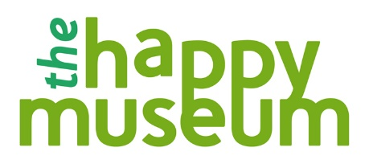

CLIMATE AWARD
Application Form
Name
Email
Contact Number
Project Name
Project website or links to supporting media*

Where is/was the project based?

Your relationship to the project

General project description (150 words max)

How does it respond to the award aims above, considering the principles of Happy Museum and and/or Culture Declares Emergency? (200 words max)

What can you tell us about its impacts so far? This could include any stats, numbers of participants or evaluations you would like to link to (200 words max)

Anything else you want to tell us about the project/people involved (200 words max)

*Please send us a maximum of 3 supporting links to any images, recordings, blogs/evaluations or films associated with the project you would like to share.

