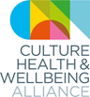 CHWA 2020 AWARDS
We are excited to announce our first ever annual awards for the CHWA 2020 Conference, taking place in Derby on 19-20th March 2020. Working with our award partners, we aim to showcase good practice and people who are leading the way in creating a culture of care for each other, their communities and the world.

Collective Power Award in partnership with Ideas Alliance
The need to work collaboratively and share resources and knowledge to address both local and national challenges is clear. This award aims to recognise a project or programme in which partnership working has improved the health and wellbeing of individuals or communities. In collaboration with the Ideas Alliance, we are looking for inspiring projects or programmes that have brought together different fields. Submissions must involve culture or the arts, and they must engage with health, care or wellbeing but the partnership might also involve organisations or individuals engaged with activism, education, social justice or any other relevant sectors to bring about change. The key is meaningful partnership across different fields or disciplines. As part of this award, all shortlisted projects will be showcased nationally by the Ideas Alliance on their online Ideas Hub, as well as the Culture, Health & Wellbeing Alliance, to share good practice and champion a range of exciting initiatives from across the country.
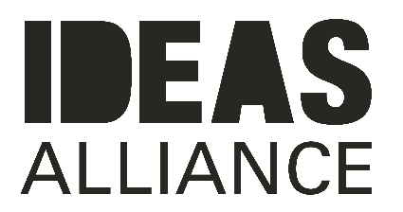
The Ideas Alliance is a social enterprise that promotes the benefits of collaborative and strengths-based and community driven approaches. We deliver projects and training with councils, charities and local organisations supporting them engage collaboratively with local people, co-design services and find solutions to social issues. We use storytelling methods to find out what matters to people, helping to connect data to real emotion that uncovers powerful perspectives and evidence to drive positive change locally.

Since our inception in 2017, we have engaged with over 6,500 people through different projects with organisations across the country and we have published over 300 articles via the Ideas Hub, our online space for publishing case studies, interviews, blogs and reports about people getting on and making things happen.

Notes for Applicants:
- Projects or programmes need to be based in the UK and to have taken place in the last two years.
- Projects or programmes can be ongoing but need to be able to demonstrate impact or change.
- Shortlisted applicants will receive discounted ticket rates. If tickets are purchased prior to announcement, money will be reimbursed.
- There will be four shortlisted projects and one winner for each of the three awards.
- The awards are an opportunity to showcase your work nationally. We will be promoting and celebrating all shortlisted nominations and winners in the CHWA Bulletin (February and March 2020) and the shortlisted entries will be published on our website and via our social media channels.
- All shortlisted projects for the Collective Power Award will also be shared via the Ideas Hub and Ideas Alliance networks.

Important Dates for Applicants:
Submission deadline is 5pm, Monday 24th February 2020. Please email this form to info@culturehealthandwellbeing.org.uk
Shortlisted applicants will be contacted by the Alliance soon after and their projects published on the CHWA website.
Winners will be announced at the evening event of the CHWA 2020 Conference: A Culture of Care on Thursday 19 March 2020 and further promoted on the CHWA websites and networks.
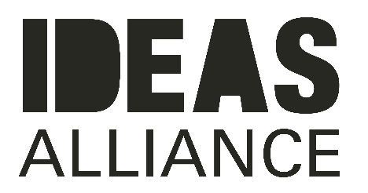
COLLECTIVE POWER AWARD
Application Form
Name
Email
Contact Number
Project Name
Project website or links to supporting media*

Where is/was the project based?

Your relationship to the project

List of Partners/Collaborators

General project description (150 words max)

How does it respond to the award aims? (200 words max)

What have been its impacts so far? (150 words max)

Any stats associated (evaluation statistics, numbers taking part etc.)

Anything else you want to tell us about the project/people involved (200 words max)

*Please send us a maximum of 3 supporting links to any images, recordings, blogs/evaluations or films associated with the project you would like to share.

