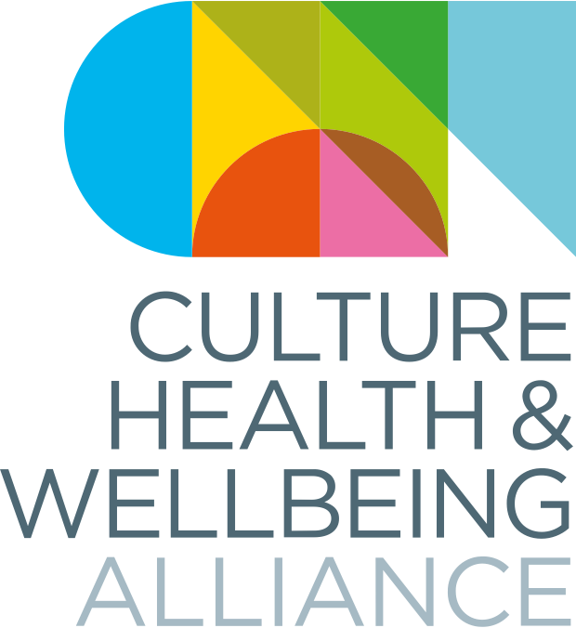

Making Change National Conference
11 – 13 October 2023
Culture, Health & Wellbeing Alliance

Speaker Information Pack

Contents

Welcome 3
CHWA’s values 4
Caring for you – covid and other illness 5
Getting here 5
Accommodation 5
General event information 6
Programme 6
Biographies 6
Venues 6
Guidance for speakers – inclusivity and accessibility 8
Language statement 8
Accessibility 9
Making your work accessible 9
Powerpoint 10
Captioning 10
Venues and spaces 11
Room facilities 15
Meet our staff 17

Appendix 1 - Venue Guide / Timetable………………………………………………… ……………………………20

Welcome

The Culture, Health & Wellbeing Alliance (CHWA) is thrilled to be hosting another in-person national conference in October, and to have secured such a wide variety of speakers who all come to creative health from a variety of disciplines, roles and industries, and with a range of skills and experiences.

We know that large events can come with a whole host of excitements, worries, anxieties and expectations to be ‘on,’ which can sometimes drain energy and limit what we take away. We also know they can feel daunting if you are early on in your career or if you don’t know many people.

Along the theme of Making Change, we have put a lot of time and thought into how we can make the conference as accessible, inclusive, enjoyable and thought provoking as possible for everyone involved, as well as deconstructing some of the common, often inherited, ideas around what a conference ‘should’ do, be and look like. This pack should help give some guidance about the kind of environment and atmosphere we’re trying to promote. If you have any questions or concerns, please don’t hesitate to get in touch via fiona@culturehealthandwellbeing.org.uk

Many thanks,

The CHWA Team

CHWA’s values

We are:

- Collaborative
- Caring
- Inclusive
- Committed to positive social change

This means we’re promoting:

- A relaxed, informal atmosphere – including quiet spaces, avoiding over-programming, encouraging periods of reflection, creativity, rest, and play.

- An authentic approach and a sense of inclusion and belonging – we want attendees, staff and speakers to make genuine connections. We therefore invite you to ‘come as you are’ – there’s no need for business/work attire, and we invite you to bring your whole self, not just your work self, to the experience – as much as you feel comfortable to of course!

- We understand that we all have rich lives outside of our work, which will include unique family arrangements, challenges, or other responsibilities to ourselves and others. Please feel free to that the time needed to balance these at any point in the conference.

- A climate conscious event – all food and refreshments will be vegetarian with a vegan option. Please note there will be no bottled water provided – we advise you to bring a refillable water bottle. We are trying to eliminate unnecessary waste, and ask you to consider this when planning your involvement.

Caring for you – covid and other illness

We want all attendees and staff to feel comfortable and safe throughout the event. There has been a rise in Covid cases recently, so would encourage all attending to pre-test, and ask you to help protect others by not attending if you have Covid or any Covid or flu-like symptoms.

Similarly, we understand some people may be anxious about being in busy spaces – you are very welcome to wear a mask, or do whatever feels right for you to help you feel safe.

Getting here

The nearest train station to the conference venues is Barnsley Central, which is about a 5-minute walk from each of the conference host venues. This short video gives walking directions from the interchange to Barnsley Civic.

A member of the CHWA team will be on hand at Barnsley Interchange at key arrival times to direct people to the venue.

You can find lots more detailed information on travel, including bus services, car parks and information for blue badge holders on our helpful information page.

Accommodation

Please note speakers are responsible for their own travel and accommodation, unless alternative arrangements have been agreed with CHWA. If you are intending to stay overnight, we advise you to book early, as town centre accommodation is limited. Accommodation recommendations can be found here.

General event information

Programme
A full copy of the conference programme (including breakout descriptions) can be downloaded or listened to here. To help manage numbers and for practitioners to prepare, breakout sessions must be prebooked by Friday 29th September via http://bookwhen.com/chwa. After this date we cannot guarantee availability of breakouts. If the breakout slot you would like to book is full, please email fiona@culturehealthandwellbeing.org.uk to add your name to the waiting list.

Biographies
Speaker biographies can be found via the conference page on our website, here.

Venues
Our host venues for the conference are Barnsley Civic, Hanson St, Barnsley S70 2HZ on 11th and 12th Oct (Access Guide Here), and Parkway Cinema, 62 Eldon St, Barnsley S70 2JL on 13th Oct (Access Guide Here). Breakout sessions will take place in the following additional venues:

- Digital Media Centre: County Way, Barnsley, S70 2JW - Access Guide here
Google Map DIrections

- Lightbox @ The Library: The Glass Works, Barnsley, S70 1GW - Access Guide Here
Google Map DIrections

- The Cooper Art Gallery: Church Street, Barnsley, S70 2AH – Access Guide Here
Google Map Directions

- Barnsley Town Hall: Church Street, Barnsley, S70 2TA – Access Guide Here
Google Map Directions

- Experience Barnsley Museum – Inside Barnsley Town Hall – Access Guide Here
Google Map Directions

- Creative Recovery, Prospect Street Community Centre, Barnsley, S70 2NR
Google Map Directions

Locations for all breakout sessions can be found as part of the programme PDF or at the end of this document in Appendix 1. There will be a walking bus from The Civic to Parkway Cinema on the Friday morning after the breakout sessions.

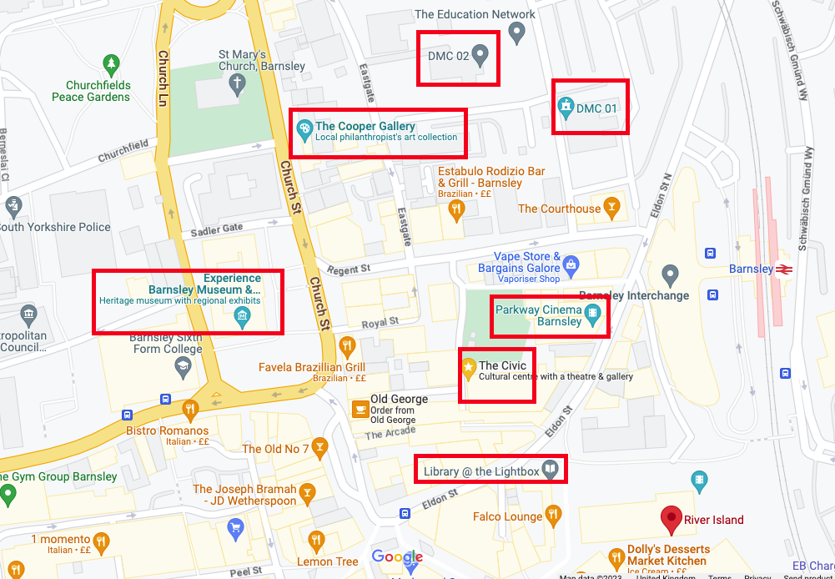

Guidance for speakers – inclusivity and accessibility

CHWA aims to be collaborative; caring; inclusive; and committed to positive social change. These are our values as an organisation and it’s essential you feel comfortable with this, and that you feel you can contribute to the event in this way. Our understanding of inclusion is to embrace and celebrate diversity of all people irrespective of race, gender, disability, medical or any other characteristic. It is about giving access and opportunities and dismantling of discrimination, intolerance and barriers at all stages of the work.

Language statement

CHWA recognizes the complexities, nuance and sensitivity needed, as well as the limitations of the English language when it comes to inclusion and access. We acknowledge that language is a continuously evolving and changing area, and that it cannot and must not exist in isolation of the wider contexts of health, culture, poverty, discrimination, history and politics.

We understand that there is implicit and systematic bias within many of our societal structures, including language, and we are committed to learning from the radical shifting movements to continue to do better for individuals and groups that experience this bias. We also know we won’t always get it right, so please tell us if there’s something we’ve missed. We ask speakers to help create an inclusive environment through thoughtful and factually correct use of language. CHWA will be using the phrase ‘global majority,’ and ask that speakers adopt this description also. For more information, please see Global Majority; Decolonising the language and Reframing the Conversation about Race (Campbell-Stevens 2020).

We encourage speakers to:
- Avoid use of derogatory, outdated, generalised or offensive descriptors when talking about a specific demographic
- State their preferred pronouns on introduction if they wish
- Self-identify and describe freely on introduction if they wish
- Avoid the use of inherently gendered terms, such as ‘mankind’
- Bring an open approach, and a willingness to be flexible/stay curious about other people’s views and preferences
For a comprehensive guide to inclusive language, CHWA recommends Oxfam’s Guide to Inclusive Language.

Accessibility

CHWA follows the social model of disability, which states that a person is ‘disabled’ by the structure and barriers in society which can be changed and eliminated, rather than by an illness, condition or impairment which they may have. We are actively working to ensure this event has access embedded at its core, rather than as an afterthought, We have been working with Cloverleaf Advocacy, and our conference working group who have advised us at all stages.
We ask all contributors to bear this in mind when planning and delivering their sessions.

For more information on the social model of disability, see NDACA’s short animation, shared by Shape Arts, or Unlimited’s animation on removing barriers to access.

We have a variety of access support available for both speakers and attendees, and are happy to have individual conversations around access if that’s helpful for you. For more information on our access approach, please see our access page.

In particular, there will be a quiet room available at all times at Barnsley Civic, as well as a safe space at Lightbox @ the Library. A co-working desk space with free refreshments is available for the whole conference at Digital Media Centre 2. Wheelchair charging is also available in the Lightbox @ the Library.

Making your work accessible

We want to make sure everybody feels safe, included and cared for whilst at the event. Please see some general tips below on an accessible approach

- Avoid using abbreviations, acronyms or ‘industry speak’; or, if you do need to use these, provide clear explanations
- If your session includes hand-outs, please consider having large print / easy-read versions of these to hand
- If your contribution covers distressing topics, let CHWA know of any content disclosures which might be included
- If your contribution includes physical elements, offer adaptations or freedom for participants to do whatever feels comfortable for them.

Powerpoint

We actively discourage speakers from using excessive visual aids or dense powerpoint presentations. If possible, do not use powerpoint. – DISCUSSION BASED If visual aids are needed, please keep them brief and consider the following:

- Please do not use italics. This can be difficult to read on many screen readers.
- Avoid unusual fonts, small print and difficult to read colour combinations, such as blue and yellow.

Captioning

All conference panels will be live captioned by My Clear Text. If you do intend to use powerpoint as part of your panel presentation, please download and use the template provided by My Clear Text, to ensure enough space for captioning.

Due to the complex technical setup required for the live captioning, all panelist powerpoints MUST be sent to fiona@culturehealthandwellbeing.org.uk by 5pm Fri 6th October, or they cannot be included.

NOTE: If you are running a breakout session or workshop, you are not required to send us your powerpoint. Breakout leaders will need to provide any visuals on their own device. We also advise you to bring any adaptors you have.

For more information on how to make your visual aids accessible, see Ability Net’s ‘Creating Accessible Documents’ Guide

Venues and spaces

Please see below details of the various breakout spaces.

Barnsley Civic – Assembly Room

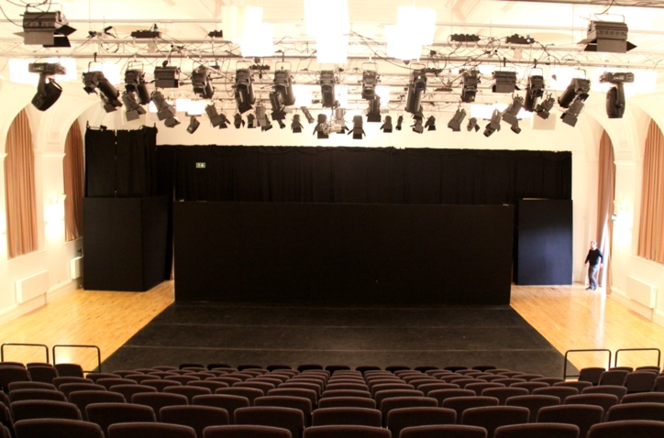

Barnsley Civic – Panorama

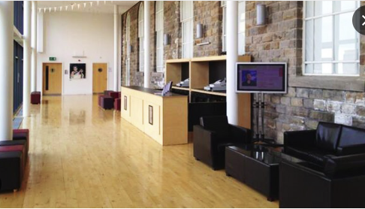

Barnsley Civic – Room 305

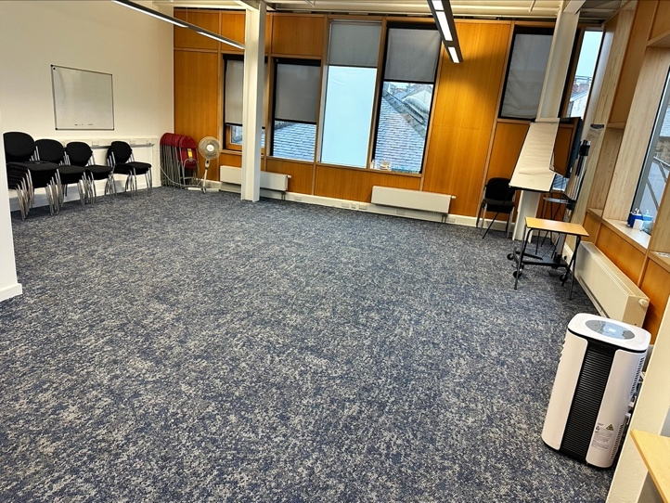

Barnsley Civic – Hanson Room

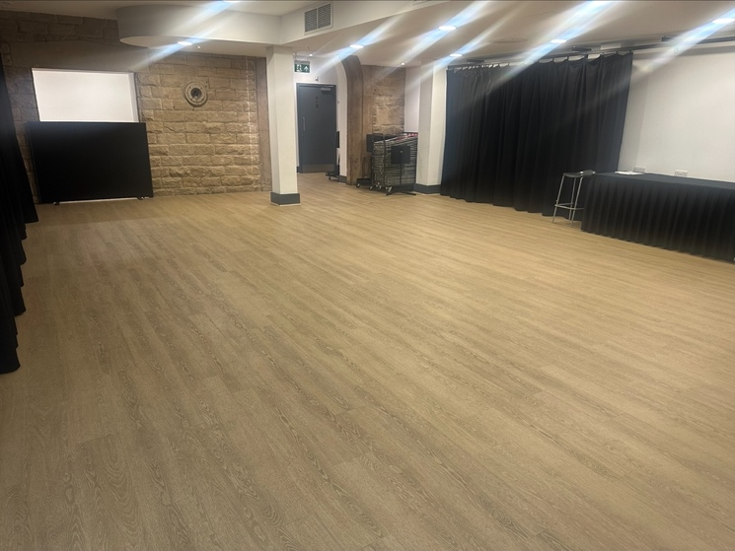

Barnsley Civic – Creation Space

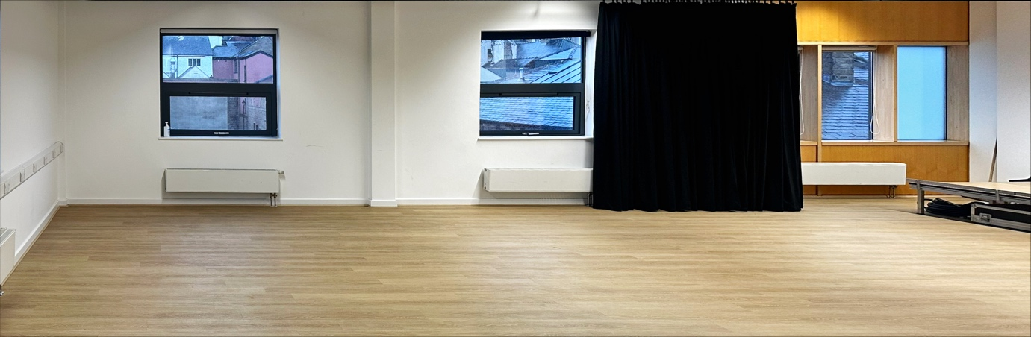

Library @ the Lightbox – Event Space

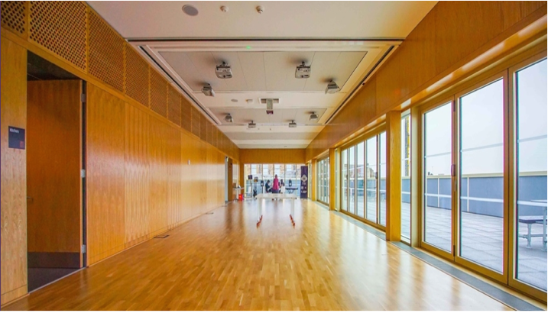

Library @ the Lightbox – ground / first floor space

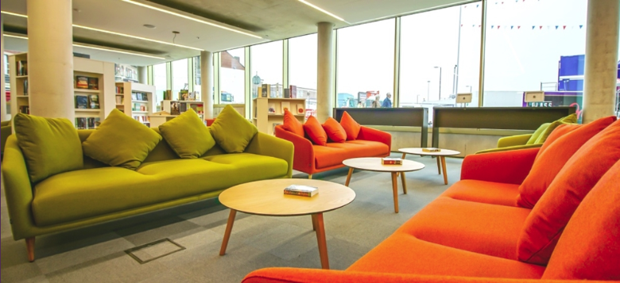

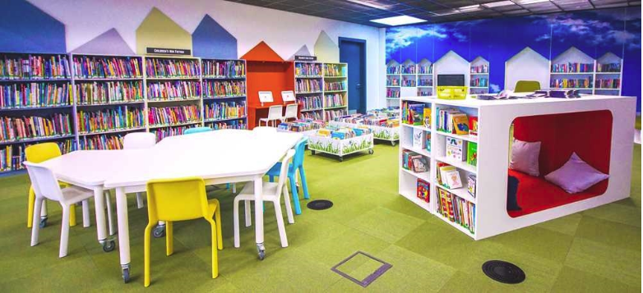

Digital Media Centre – The Murray

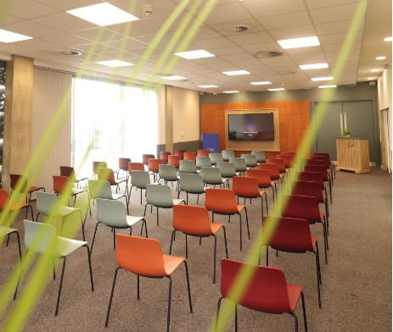
Digital Media Centre - The Hub

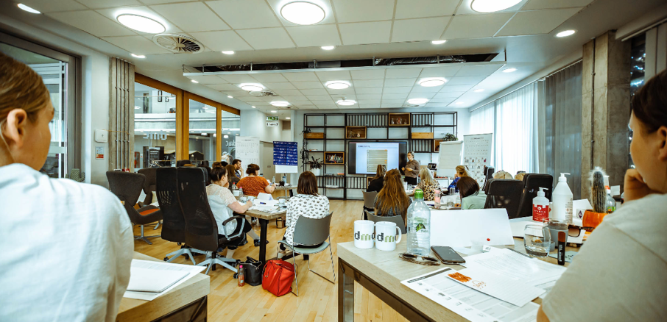

Digital Media Centre – Bramah Room

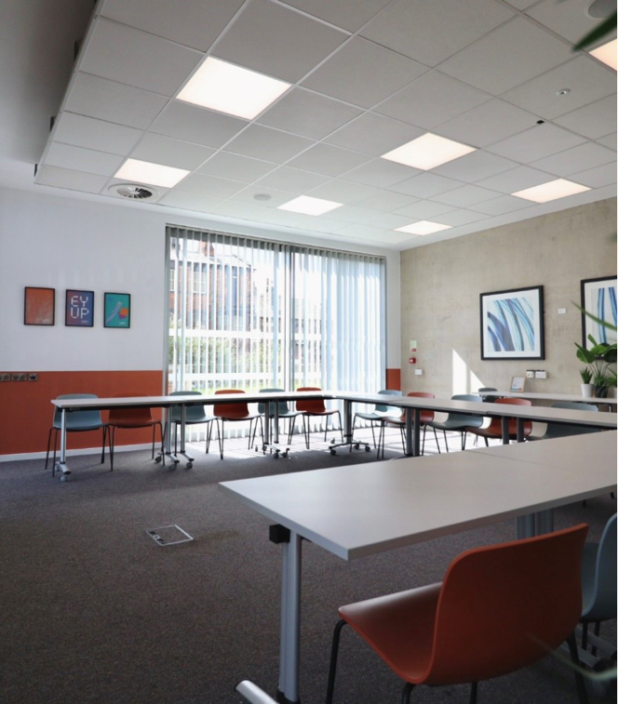

Digital Media Centre – Walker Room
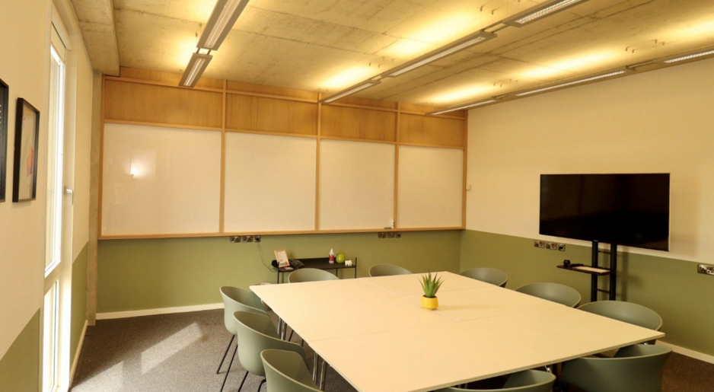

Sadler Room, Cooper Art Gallery
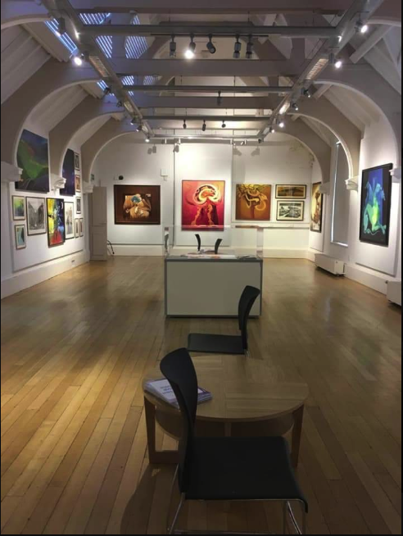

Event Space, Barnsley Town Hall

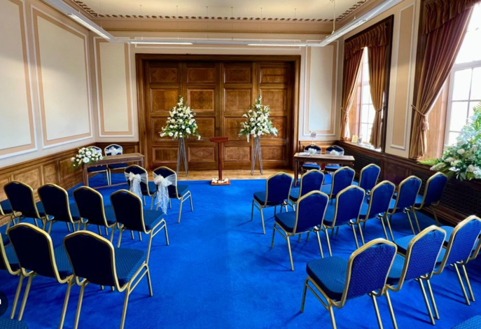

Room facilities

Please note we are using several breakout spaces across multiple venues and the facilities available in each breakout space will vary. All rooms will have pens, paper and a flipchart. You will need to supply any additional materials specific to your breakout, which can be invoiced for, as per your contract. Breakout leaders will also need to supply their own laptop if needed. If you have laptop adaptors and Bluetooth speakers, we suggest bringing these also. Please also ensure any electrical equipment and props are of a good, safe working standard with no visible defects or exposed wires.

Room allocation will be based on breakout pre-sign ups, and will be sent to all speakers by 2nd October.

 | Screen / Projector | Adaptors | Sound system | Microphone | Securing things to walls
Civic, Assembly Room | Yes | HDMI | Yes | Yes | White tack only
Civic Creation Space | Yes | HDMI | Yes – notice needed | No | White tack only
Civic Room 305 | Yes | HDMI | No | No | White tack only
Civic Hanson Room | No | - | No | No | White tack only
Civic, Panorama | No | - | No | No | White tack only
Sadler Room | Yes | HDMI, Bluetooth | No | No | No
Library Event Space | Yes | HDMI and projector | Yes – request in advance | Yes – request in advance | No
Library ground / first floor
DMC, All rooms | Yes | HDMI, DVI, VGA, wireless | Yes – notice needed | Yes – notice needed | On glass windows only

Meet our staff

CHWA are a small core team, who will be very active before and during the conference to help welcome you and make sure you feel comfortable. If you need anything throughout the conference, please do ask a member of staff or one of our fantastic volunteers.

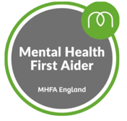
Fiona Moon - National Coordinator
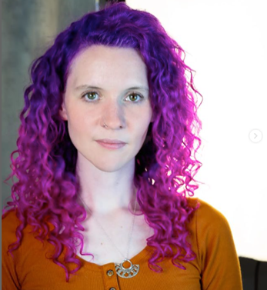

Fiona is a writer and maker with a background in creative learning management, producing and arts outreach for wellbeing, as well as facilitating her own community projects. She has a Masters in Playwriting from Central School of Speech and Drama and in 2022 founded and ran Rooted in Guildford; a month-long arts and mental health festival engaging over 2000 community members. Her main focus since joining CHWA in June has been organizing the conference. She is passionate about access to culture and creativity as a human
right, is a big reader, and a massive dog lover. She is also a Mental Health First Aider, trained in Trauma Informed Practice and a Designated Safeguarding Officer. She’s most excited about the variety of the programme at Making Change, and hopes to get creative in a workshop in between all the running around!

Kheyla Anderson - Administrator
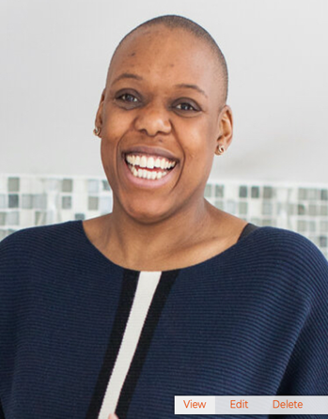

As the newly appointed administrator for CHWA, Kheyla is excited to attend her first conference with them and is particularly looking forward to the Kazzum Arts led breakout around creating a trauma-informed organisation. She is the founder of Mother Nature’s Recipes a company making room for the necessity of self-care and community in womanhood from a holistic perspective. She also co-founds Birthing In Colour, a charitable organisation that creates safe spaces online for black and brown birthing bodies.

Rachel Howfield Massey
North Regional Lead
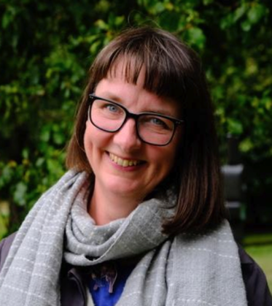

Rachel has over 20 years’ experience of working in Creative Health as an artist,
project coordinator and consultant. Her work in the culture sector includes leading Yorkshire Sculpture Park’s Art and Wellbeing programme and coordinating a county-wide creative health programme for Arts Derbyshire. She also worked in the health sector as a manager at Live Well Wakefield, a large-scale social prescribing programme. She leads Other Ways to Walk, which she founded to help people connect with nature using creative & mindful approaches. Her practice includes visual art, podcasts, writing and interdisciplinary collaboration. Rachel is a qualified Mindfulness Instructor, Mental Health First Aider, Walking for Health Leader and Forest Bathing Guide. Working a lot in the South Yorkshire region, she’s most excited to meet new local practitioners at Making Change, and hear about their wonderful practice!

Victoria Hume
Executive Director
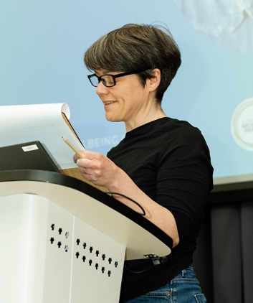

Victoria was an arts manager in the NHS for 15 years before pursuing arts in health in South Africa for 5 years, including setting up a new module in hospital-based performance for the University of the Witwatersrand and managing a three-year, Wellcome-funded drama and diabetes programme with Chris Hani Baragwanath Hospital in Soweto. She is also a composer and researcher specialising in culture, health and wellbeing, and has a Masters in Music and Health Communication focused on hospital-induced delirium.
She is a Research Associate in the Medical Humanities at WiSER (Wits Institute for Social & Economic Research), and continues to write and release music through Lost Map Records, based on Eigg.

Making Change: Culture, Health & Wellbeing Alliance National Conference
11th–13th October 2023, Barnsley

VENUE GUIDE

Please note all panel talks, roundups and refreshment breaks will take place at our host venues:
- Wednesday 11th and Thursday 12th October: Barnsley Civic
- Friday 13th October: Parkway Cinema

Quiet and safe places are available throughout the conference at Barnsley Civic and Barnsley Library @ The Lightbox. Access guides to all venues can be found via our access page.

Wednesday 11th October 2023: Breakouts

16.15–17.15 | Make Your Own Creative Health Toolkit | The Hub – Digital Media Centre 2
 | Change, Act! – Transformational Play:  The Theatre Games of Boal as a Call to Social Change | Murray Room – Digital Media Centre 2
 | Rosie Carnall – Pop Up Philosophy Café | Sadler Room – Cooper Art Gallery
 | Imrana Mahmood – Cultural Diversity in the Arts: Beyond the Tick Box Exercise | Barnsley Civic, Creation Space
 | Alex Evans, Kazzum Arts – How to Create a Trauma Informed Organisation | Barnsley Civic, Assembly Room
 | Emily O’Shea – Equitable for All: Embedding Access into Live and Cultural Events | Barnsley Civic, Room 305
 | Kelly Amoss – Adoption Friendly Frameworks in Creative Health | Walker Room – Digital Media Centre 2
 | Jane Thakoordin: Artist in Residence: Protest Banner Making Workshop | Barnsley Civic, Panorama Space (far end)

Wednesday 11th October 2023: Evening

18:45 onwards | Takeover of Barnsley Town Hall | Barnsley Town Hall / Barnsley Museum
 | Evening Meal (must be prebooked by 29th September) | Council Chamber, Town Hall
 | Cross the Sky Theatre Company: Film Showing  Suffolk Artlink: Film Showing | Town Hall Council Chamber
 | Jane Thakoordin, Artist in Residence – Protest Banner Making Workshop | Council Chamber, Town Hall
 | leon clowes – Queer Mats: A Creative Exploration of Our Relationship with Alcohol | Council Chamber, Town Hall
 | Feels Like Home Art Activity | Barnsley Museums Learning Lab
 | Barnsley Museum Collection – Spotlight Tours  Plant a Promise – Micro-volunteering Pledge Activity  Hear my Voice – Poetry Buffet | Barnsley Museums  Sadler Room, Cooper Art Gallery

Thursday 12th October: Breakouts

11.45 – 12.45 | National Centre for Creative Health – Creative Health Toolkit | Barnsley Civic, Assembly Room
 | Julie Tolhurst, Public Health Barnsley & Rachel Massey, The Culture, Health & Wellbeing Alliance – A Strategic Approach to Creativity & Wellbeing Week | Murray Room – Digital Media Centre 2
 | Emma Bentley Fox – Confessions: A Trauma Informed Writing Workshop | Bramah Room, Digital Media Centre 2
 | Reach In and Reach Out (RIRO) | Barnsley Civic, Room 305
 | The Artists Represent Recovery Network (ARRN) | Event Space, Barnsley Library @ the Lightbox
 | Vicky Hunter – Mapping and Moving: Fostering wellbeing through body-site connections | Barnsley Civic, Hanson Room
 | People Dancing – The Power of Partnership with People: Creating Authentic Partnerships Alongside People Living with Parkinson’s | Barnsley Civic, Creation Space
15.30 – 16.30 | Jane Thakoordin: Artist in Residence: Protest Banner Making Workshop | Barnsley Civic, Room 305
 | Julian West and Michael Cunliffe – Where is the Artist? The Role of the Practitioner when Co-Creating with Non-Professional Participants | Event Space, Barnsley Library @ the Lightbox
 | Barnsley Museums – Art on Loan: Rethinking Access to Art for Older People | Cooper Art Gallery, Sadler Room
 | Ruth Flanagan – Lived Experience as a Tool for Best Practice: Healing Beyond the Medical Model | Barnsley Civic, Creation Space
 | Viv Reiss, Sarah Derbyshire, Laura Waters & Guy Noble – Collaboration Commissioning Change: How Working Collaboratively Can Inform Policy | Barnsley Civic, Assembly Room
 | Hannah Gaunt – Connect & Reflect: A Safe Space for Imaginative Thinking, Problem Solving and Nurturing Quality Practice | Bramah Room, Digital Media Centre 2
 | Tim Joss – Increasing Organisational Resilience and Rigour in Creative Health | Murray Room, Digital Media Centre 2

Thursday 12th October 2023: Evening

18.00 onwards | Un-conference @ The Lightbox | Barnsley Library @ the Lightbox
18:30 | Table Talk with Victoria Hume – The Culture, Health & Wellbeing Alliance  Could You Be Our Next Regional Champion? | Ground Floor, Barnsley Library  @ the Lightbox
18.30 | Sharleen Shaha, hoot creative arts: Speak Our Music Workshop | Event Space, Barnsley Library  @ the Lightbox
19:00 | Jane Thakoordin: Artist in Residence: Protest Banner Making Workshop | Ground Floor, Barnsley Library  @ the Lightbox
19:00 | Table Talk – Becky and YP | Ground Floor, Barnsley Library  @ the Lightbox
19:30 | Table Talk with National Centre for Creative Health – Meet your new Creative Health Associates | Ground Floor, Barnsley Library  @ the Lightbox
20:00 | Table Talk with the LENs: Exploring the role of Lived Experience in Creative Health & Co-Production | Ground Floor, Barnsley Library  @ the Lightbox
20:00 | Performance Rose Condo: How to Starve an Artist | Event Space, Barnsley Library  @ the Lightbox

Breakouts: Friday 13th October

9.30 – 10.30 | SPILL, A Creative Mess Making Workshop with Creative Recovery | Creative Recovery, Prospect Street Community Centre
 | Royal Liverpool Philharmonic – 15 Years of Music in Healthcare – A Practical Workshop | Barnsley Civic, Room 305
 | Karen Irwin, Live Music Now – The Lullaby Project: Improving Perinatal Mental Health Through Song Writing | Event Space, Barnsley Library @ the Lightbox
 | Jane Willis – Introducing the Creative Health Quality Framework | Murray Room, Digital Media Centre 2
 | Maria Pasiecznik Parsons / Dr Richard Coaten – Cocreating the Practice Handbook for Creative Arts and Dementia | The Hub, Digital Media Centre 2
 | Nick Cutts – Music as an Intrinsic Part of Caring | The Sadler Room, Cooper Art Gallery
 | Vikki Parker – Doodle Café: Wellbeing Wisdom | Barnsley Civic, Creation Space

Barnsley Civic: https://goo.gl/maps/E6sWLAua5cZD66N56

Parkway Cinema: https://goo.gl/maps/gxaHSUtDMQnCYxrz6

Digital Media Centre 1: https://goo.gl/maps/pZenAxoMVJNQAwcq9

Digital Media Centre 2: https://maps.app.goo.gl/RrZwkBNQ5KJdNa2v6

The Cooper Gallery: https://goo.gl/maps/Mocxm4gQZq2jqyj29

Barnsley Town Hall: https://goo.gl/maps/8fWbUgDzrAne3Jgd6

Lightbox @ The Library: https://goo.gl/maps/vBDTZiwm9A16tfjA6

Creative Recovery: https://maps.app.goo.gl/ZJinfqT4nK1fkLBc7

