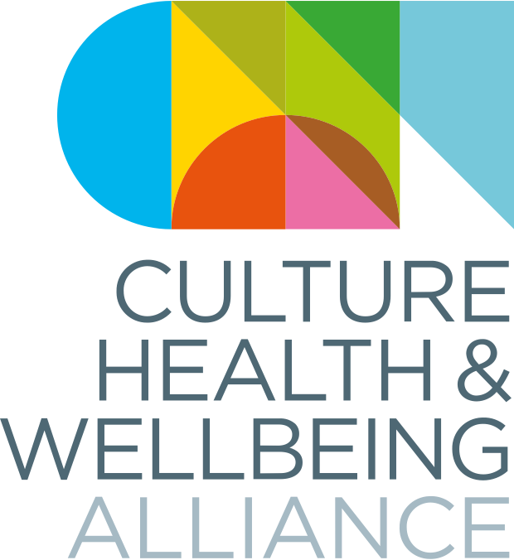

Making Change National Conference
11 – 13 October 2023
The Culture, Health & Wellbeing Alliance

Attendee Information Pack

Contents
Welcome 3
CHWA’s values 4
Caring for you – Covid and other illness 5
Getting Here 5
Pre-Conference Resource Pack 5
Accommodation/Parking in Barnsley 6
General Event Information 6
Programme 6
Biographies 6
Venues 6
Inclusivity and Accessibility 8
Language Statement 8
Accessibility 9
Visual Story 9
Trigger Warnings 9
Quiet Spaces 10
Hearing Loop 10
Wheelchair Charging 10
Prayer Space 10
Meet our Staff 11
Comments and Feedback 14
Appendix 1 – Summarised Programme and Timetable 15

Welcome

The Culture, Health & Wellbeing Alliance (CHWA) are thrilled to be hosting another in person national conference in October, and to have secured such a wide variety of speakers who all come to creative health from a variety of disciplines, roles and industries, and with a range of skills and experiences.

We know that large events can come with a whole host of excitements, worries, anxieties and expectations to be ‘on,’ which can sometimes drain energy and limit what we take away. We also know they can feel daunting if you are early on in your career or if you don’t know many people.

Along the theme of Making Change, we have put a lot of time and thought into how we can make the conference as accessible, inclusive, enjoyable and thought provoking as possible for everyone involved, as well as deconstructing some of the common, often inherited, ideas around what a conference ‘should’ do, be and look like. This pack should help give some guidance about the kind of environment and atmosphere we’re trying to promote. If you have any questions or concerns, please don’t hesitate to get in touch via fiona@culturehealthandwellbeing.org

Many Thanks,

The CHWA Team

CHWA’s values

We are:

- Collaborative
- Caring
- Inclusive
- Committed to positive social change

This means we’re promoting:

- A relaxed, informal atmosphere – including quiet spaces, avoiding over-programming, encouraging periods of reflection, creativity, rest, and play.

- An authentic approach and a sense of inclusion and belonging – We want attendees, staff and speakers to make genuine connections on a human level. We therefore invite you to ‘come as you are’ – there’s no need for business/work attire, and we invite you to bring your whole self, not just your work self, to the experience!

- We understand that we all have rich lives outside of our work, which will include unique family arrangements, challenges, or other responsibilities to ourselves and others. Please feel free to that the time needed to balance these at any point in the conference.

- A climate conscious event – All food and refreshments will be vegetarian with a vegan option. Please note there will be no bottled water provided – we advise you to bring a refillable water bottle. We are trying to eliminate unnecessary waste, and ask you to consider this when planning your involvement.

Caring for you – Covid and other illness

We want all attendees and staff to feel comfortable and safe throughout the event. There has been a rise in Covid cases, so would encourage all attending to pre-test, and ask you to help protect others by not attending if you have Covid or any Covid or flu-like symptoms.

Similarly, we understand some people may be anxious about being in busy spaces – you are very welcome to wear a mask, or do whatever feels right for you to help you feel safe.

A number of CHWA and venue staff are first aiders. If you feel unwell whilst at the event, please ask a member of CHWA staff to help you.

Getting Here

The nearest train station to the conference venues is Barnsley Central, which is about a 5-minute walk from each of the conference host venues. This short video gives walking directions from the interchange to Barnsley Civic.

A member of the CHWA team will be on hand at Barnsley Interchange at key arrival times to direct people to the venue.

You can find lots more detailed information on travel, including bus services, car parks and information for blue badge holders on our helpful information page.

Pre-Conference Resource Pack

CHWA has created a Pre-Conference Resource Pack, full of useful articles, podcasts, reports and more, which you may wish to look at during your journey.
TOP TIP

We have also collaborated with Heart of England Community Rail Partnership and Emily Kaye Illustrations to create a creative activity booklet and series of video tutorials to help ease travel anxiety and make use of your train time!

Accommodation/Parking in Barnsley

Please see our helpful information page for practical information about staying in Barnsley. If you are intending to stay overnight, we advise you to book early as town centre accommodation is limited.

General Event Information

Programme

A full copy of the conference programme (including breakout descriptions) can be downloaded or listened to here. To help manage numbers and for practitioners to prepare, breakout sessions must be prebooked by Friday 29th September via http://bookwhen.com/chwa. After this date we cannot guarantee availability of breakouts. If the breakout slot you would like to book onto is full, please email fiona@culturehealthandwellbeing.org.uk to add your name to the waitlist.

A summarized programme and timetable are listed at the end of this document.

Biographies

A full list of speaker biographies can be found on our website.

Venues

Our host venues for the conference are Barnsley Civic, Hanson St, Barnsley S70 2HZ on 11th and 12th Oct (Access Guide Here), and Parkway Cinema, 62 Eldon St, Barnsley S70 2JL on 13th Oct (Access Guide Here). Breakout sessions will take place in the following additional venues:

- Digital Media Centre: County Way, Barnsley, S70 2JW - Access Guide here
Google Map DIrections

- Lightbox @ The Library: The Glass Works, Barnsley, S70 1GW - Access Guide Here
Google Map DIrections

- The Cooper Art Gallery: Church Street, Barnsley, S70 2AH – Access Guide Here
Google Map Directions

- Barnsley Town Hall: Church Street, Barnsley, S70 2TA - Access Guide Here
Google Map Directions

- Experience Barnsley Museum – Inside Barnsley Town Hall Access Guide Here
Google Map Directions

- Creative Recovery, Prospect Street Community Centre, Barnsley, S70 2NR

Locations for all breakout sessions can be found as part of the programme PDF, and pictures of all spaces are available in our visual story. There will be a walking bus from The Civic to Parkway Cinema on the Friday morning after the breakout sessions.
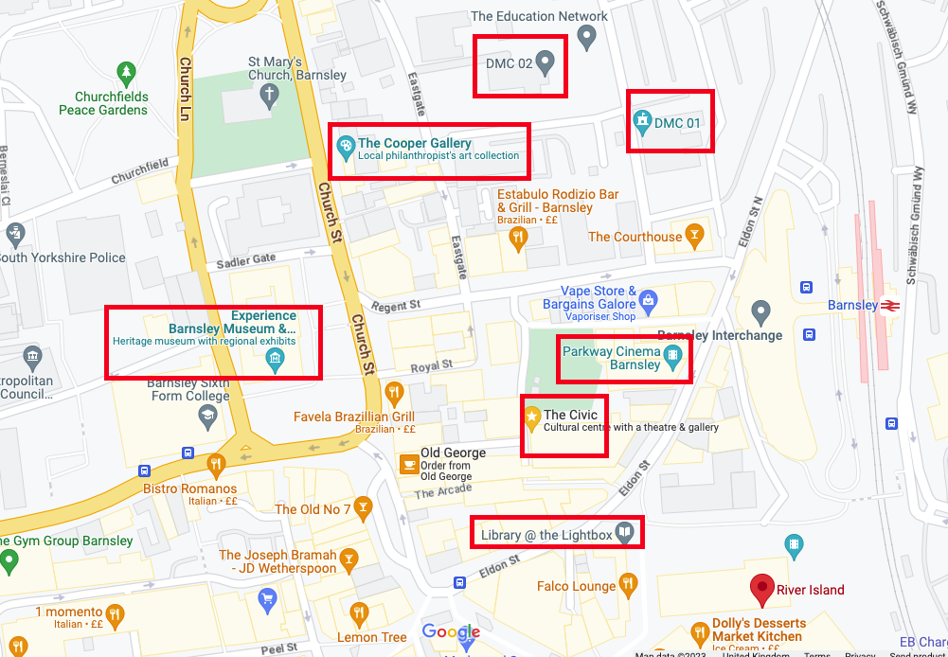

A timetable of breakout sessions is available on our website or at the end of this document.

Inclusivity and Accessibility

CHWA aims to be collaborative; caring; inclusive; and committed to positive social change. These are our values as an organisation and it’s essential you feel comfortable with this, and that you feel you can contribute to the event in this way as an attendee.

Our understanding of inclusion is to embrace and celebrate diversity of all people irrespective of race, gender, disability, medical or any other characteristic. It is about giving access and opportunities and dismantling of discrimination, intolerance and barriers at all stages of the work.

Language Statement

CHWA recognizes the complexities, nuance and sensitivity needed, as well as the limitations, of the English language when it comes to inclusion and access. We acknowledge that language is a continuously evolving and changing area, and that it cannot and must not exist in isolation to the wider contexts of health, culture, poverty, discrimination, history and politics.

We understand that there are implicit and systematic bias within many of our societal structures, including language, and we are committed to learning from the radical shifting movements to continue to do better for individuals and groups that experience this bias. We also know we won’t always get it right, so please tell us if there’s something we’ve missed. We ask speakers to help create an inclusive environment through thoughtful and factually correct use of language. CHWA will be using the phrase ‘global majority,’ and ask that speakers adopt this description also. For more information, please see Global Majority; Decolonising the language and Reframing the Conversation about Race (Campbell-Stevens 2020).

We encourage all attendees to:

- Avoid use of derogatory, outdated, generalised or offensive descriptors when talking about a specific demographic
- State their preferred pronouns on introduction if they wish
- Self-identify and describe freely on introduction if they wish
- Avoid the use of inherently gendered terms, such as ‘mankind’
- Bring an open approach, and a willingness to be flexible/stay curious about other peoples views and preferences

For a comprehensive guide to inclusive language, CHWA recommends Oxfam’s Guide to Inclusive Language

Accessibility

CHWA follows the social model of disability, which states that a person is ‘disabled’ by the structure and barriers in society which can be changed and eliminated, rather than by an illness, condition or impairment which they may have. We are actively working to ensure this event has access embedded at its core, rather than as an afterthought, We have been working with Cloverleaf Advocacy, and our conference working group who have advised us at all stages.
We ask all contributors to bear this in mind when planning and delivering their sessions.

For more information on the social model of disability, see NDACA’s short animation, shared by Shape Arts, or Unlimited’s animation on removing barriers to access.

We have a variety of access support available for both speakers and attendees, and are happy to have individual conversations around access if that’s helpful for you. For more information on our access approach, please see our access page.

Visual Story
TOP TIP
We also have a visual story available on our website. This includes pictures of
all conference spaces.

Trigger Warnings
Please see the programme and breakout descriptions for trigger warnings. Please do what you need to to manage your wellness – if you need to leave a session at any point feel free.

Quiet Spaces
There will be a quiet room available at all times at Barnsley Civic, as well as a safe space at Lightbox @ the Library. A co-working desk space with free refreshments is available for the whole conference at Digital Media Centre 2.

Hearing Loop
Hearing loops are available at Barnsley Civic and Parkway Cinema.

Wheelchair Charging
Space for wheelchair charging is available at Lightbox @ The Library.

Prayer Space
A prayer space is available at Barnsley Civic for all attendees.

CHWA will have an Access Champion and an Inclusion Champion available to assist with any issues at the event. Please let a member of the CHWA team know if you have an issue you would like to discuss.

Meet our Staff

CHWA has a small core team, who will be very active before and during the conference to help welcome you and make sure you feel comfortable. If you need anything throughout the conference, please do ask a member of staff or one of our fantastic volunteers.

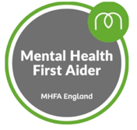
Fiona Moon - National Coordinator
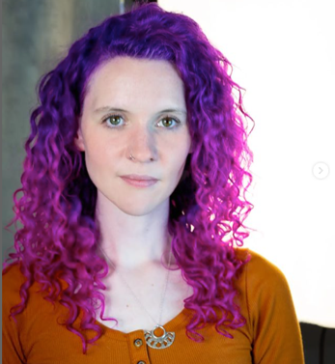

Fiona is a writer and maker with a background in creative learning management, producing and arts outreach for wellbeing, as well as facilitating her own community projects. She has a Masters in Playwriting from Central School of Speech and Drama and in 2022 founded and ran Rooted in Guildford; a month-long arts and mental health festival engaging over 2000 community members. Her main focus since joining CHWA in June has been organizing the conference. She is passionate about access to culture and creativity as a human
right, is a big reader, and a massive dog lover. She is also a Mental Health First Aider, trained in Trauma Informed Practice and a Designated Safeguarding Officer. She’s most excited about the variety of the programme at Making Change, and hopes to get creative in a workshop in between all the running around!

Kheyla Anderson - Administrator
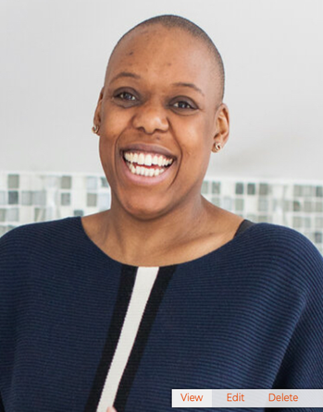

As the newly appointed administrator for CHWA, Kheyla is excited to attend her first conference with them and is particularly looking forward to the Kazzum Arts led breakout around creating a trauma informed organisation. She is the founder of Mother Nature’s Recipes a company making room for the necessity of self-care and community in womanhood from a holistic perspective. She also co-founds Birthing In Colour, a charitable organisation that creates safe spaces online for black and brown birthing bodies.

Rachel Howfield Massey
North Regional Lead
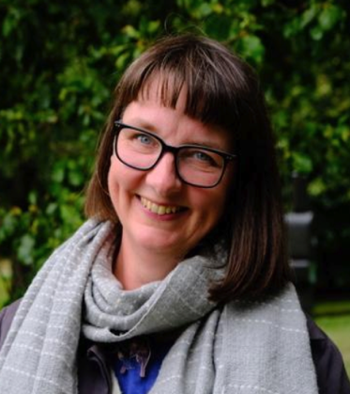

Rachel has over 20 years’ experience of working in Creative Health as an artist,
project coordinator and consultant. Her work in the culture sector includes leading Yorkshire Sculpture Park’s Art and Wellbeing programme and coordinating a county-wide creative health programme for Arts Derbyshire. She also worked in the health sector as a manager at Live Well Wakefield, a large-scale social prescribing programme. She leads Other Ways to Walk, which she founded to help people connect with nature using creative & mindful approaches. Her practice includes visual art, podcasts, writing and inter-disciplinary collaboration. Rachel is a qualified Mindfulness Instructor, Mental Health First Aider, Walking for Health Leader and Forest Bathing Guide. Working a lot in the South Yorkshire region, she’s most excited to meet new local practitioners at Making Change, and hear about their wonderful practice!

Victoria Hume
Executive Director
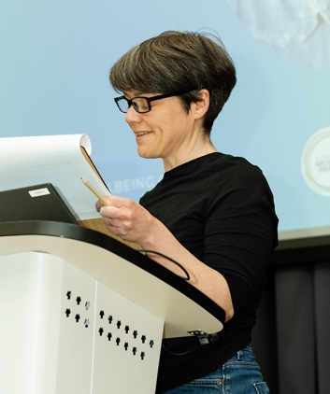

Victoria was an arts manager in the NHS for 15 years before pursuing arts in health in South Africa for 5 years, including setting up a new module in hospital-based performance for the University of the Witwatersrand and managing a three-year, Wellcome-funded drama and diabetes programme with Chris Hani Baragwanath Hospital in Soweto. She is also a composer and researcher specialising in culture, health and wellbeing, and has a Masters in Music and Health Communication focused on hospital-induced delirium.
She is a Research Associate in the Medical Humanities at WiSER (Wits Institute for Social & Economic Research), and continues to write and release music through Lost Map Records, based on Eigg.

Comments and Feedback

We really want to capture your experience of the conference to help us grow and improve for future events. There will be a variety of methods for doing this both during and post-event. Look out for the QR code below.
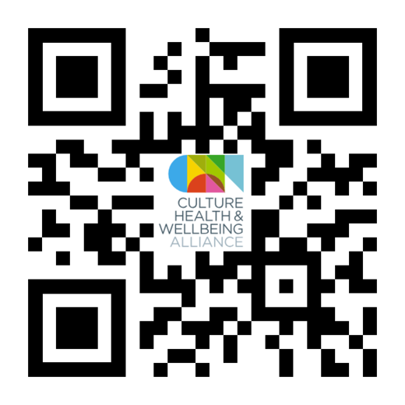
TOP TIP

Appendix 1 – Summarised Programme and Timetable

Making Change
Culture, Health & Wellbeing Alliance National Conference
11–13 October 2023

Weds 11 October 2023 – Barnsley Civic & Various Breakout Spaces

13.00 Arrivals and Registration

13.50 – 14.25 Opening Performance & Welcome

Horizon Community College, Barnsley – Streetkingz and Fusion

Councillor Steve Houghton – Council Leader, Barnsley Metropolitan Borough Council

Victoria Hume & Fiona Moon – Culture, Health & Wellbeing Alliance

14.30 – 15.35 Panel 1:
From the Roots Up – Where Values Create Systems and Structures
(content disclosure: mention of surviving child sexual abuse)

15.30 – 15.45 Wednesday Roundup

15.45 – 16.15 Tea and cake

16.15 – 17.15 Breakout Sessions 1

Lora Krasteva – Make Your Own Creative Health Toolkit

Change, Act! – Transformational Play: The Theatre Games of Boal as a Call to Social Change

Rosie Carnall – Pop Up Philosophy Café

Imrana Mahmood – Cultural Diversity in the Arts: Beyond the Tick Box Exercise

Alex Evans, Kazzum Arts – How to Create a Trauma Informed Organisation

Emily O’Shea – Equitable for All: Embedding Access into Live and Cultural Events

Kelly Amoss – Adoption Friendly Frameworks in Creative Health

Jane Thakoordin, Artist in Residence: Protest Banner Making Workshop

19.00 onwards Takeover of Barnsley Town Hall & Museum

Evening Meal provided at the Town Hall

Jane Thakoordin, Artist in Residence – Protest Banner Making Workshop

Cross the Sky Theatre Company – Film Showing

leon clowes – Queer Mats: A Creative Exploration of Our Relationship with Alcohol
(Content Disclosure: discussion of addiction/alcoholism)

Barnsley Museums – Hear My Voice Poetry Buffet, Feels Like Home Art Workshop, Plant a Promise Micro-volunteering Activity, Spotlight Tours of museum collection and AR/VR Showcase

Day 2 overleaf…
Thurs 12th October 2023 - Barnsley Civic & Various Breakout Spaces

09.00 – 09.45 Arrivals and Registration

09.45 – 10.00 Welcome

10.00 – 11.10 Panel 2:
Not a Single Tree but an Ecosystem:
Building Cooperation, Communication and Support

11:45 – 12:45 Breakout Sessions 2

National Centre for Creative Health – Creative Health Toolkit

Julie Tolhurst, Public Health Barnsley & Rachel Massey, The Culture, Health & Wellbeing Alliance – A Strategic Approach to Creativity & Wellbeing Week

Emma Bentley Fox – Confessions: A Trauma Informed Writing Workshop

Reaching Out Reaching In (RIRO)

Artists Represent Recovery Network (ARRN)

Vicky Hunter – Mapping and Moving: Fostering wellbeing through body-site connections

People Dancing – The Power of Partnership with People: Creating Authentic Partnerships Alongside People Living with Parkinson’s

13.00 – 13.45 Lunch – provided by The Yorkshire Food Company

14:00 - 15.05 Panel 3:
Creating Fertile Ground: Where Investment is Feeding New Systems

15.30 – 16.30 Breakout Sessions 3

Jane Thakoordin, Artist in Residence – Protest Banner Making Workshop

Julian West & Michael Cunliffe – Where is the Artist? The Role of the Practitioner when Co-Creating with Non-Professional Participants

Ruth Flanagan – Lived Experience as a Tool for Best Practice: Healing Beyond the Medical Model (Content Disclosure: Discussion of cancer/cancer treatment)

Sarah Derbyshire (Orchestras Live), Viv Reiss, Laura Waters & Guy Noble, National Arts in Hospitals Network – Collaboration Commissioning Change: How Working Collaboratively Can Inform Policy

Hannah Gaunt, Engage – Connect & Reflect: A Safe Space for Imaginative Thinking, Problem Solving and Nurturing Quality Practice

Barnsley Museums – Art on Loan: Rethinking Access to Art for Older People

Tim Joss, Aesop Arts & Society – Increasing Organisational Resilience and Rigour in Creative Health

16.30 – 17.00 Cakes and tea

17.00 – 17.30 End of Day Roundup

18.00 Onwards Un-conference @ The Lightbox

Barnsley Libraries – Poetry Wellbeing Parcels

18.30 Sharleen Shaha, Hoot Creative Arts – Speak Our Music: Making for Wellbeing

18.30 Drop In Table Talk: National Centre for Creative Health – Meet Your New Creative Health Associates

19.00 Jane Thakoordin, Artist in Residence – Protest Banner Making Workshop

19.30 Drop In Table Talk: Victoria Hume, CHWA – Could You Be Our Next Regional Champion?

20.00 Drop In Table Talk: The LENs – Exploring the Role of Lived Experience in Creative Health and Co-Production

20.00 Rose Condo – Performance: How to Starve an Artist

Day 3 overleaf…

Fri 13th October 2023 – Parkway Cinema & Various Breakout Spaces

09.15 – 09.30 Arrivals and Registration

09.30 – 10.30 Breakout Sessions 4

Royal Liverpool Philharmonic – Delivering Music in Healthcare Settings

Karen Irwin, Live Music Now – The Lullaby Project: Improving Perinatal Mental Health Through Song Writing

Jane Willis – Introducing the Creative Health Quality Framework

Helen Boutle, Creative Recovery – SPILL, A Creative Mess-Making Workshop

Maria Pasiecznik Parsons & Dr Richard Coaten, Creative Dementia Arts Network – Cocreating the Practice Handbook for Creative Arts and Dementia

Nick Cutts, OPUS Music – Music as an Intrinsic Part of Caring

Vikki Parker – Doodle Café: Wellbeing Wisdom

Jane Thakoordin, Artist in Residence – Protest Banner Making Workshop

10.30 – 11.00 Refreshments (hot drinks)

11.00 - 12:10 Panel 4
Bearing Fruit: Unearthing the Magic

12:15 – 13.00 Closing words: Fiona Moon, Victoria Hume & Matt Walsh – CHWA

13:00 End

Please note all panel talks, roundups and refreshment breaks will take place at our host venues:
- Wednesday 11th and Thursday 12th October: Barnsley Civic
- Friday 13th October: Parkway Cinema

Quiet and safe places are available throughout the conference at Barnsley Civic and Barnsley Library @ The Lightbox. Access guides to all venues can be found via our access page.

Wednesday 11th October 2023: Breakouts

16.15–17.15 | Make Your Own Creative Health Toolkit | The Hub – Digital Media Centre 2
 | Change, Act! – Transformational Play:  The Theatre Games of Boal as a Call to Social Change | Murray Room – Digital Media Centre 2
 | Rosie Carnall – Pop Up Philosophy Café | Sadler Room – Cooper Art Gallery
 | Imrana Mahmood – Cultural Diversity in the Arts: Beyond the Tick Box Exercise  (Please note a video will be played at the end of the workshop that includes a racial slur) | Barnsley Civic, Creation Space
 | Alex Evans, Kazzum Arts – How to Create a Trauma Informed Organisation | Barnsley Civic, Assembly Room
 | Emily O’Shea – Equitable for All: Embedding Access into Live and Cultural Events | Barnsley Civic, Room 305
 | Kelly Amoss – Adoption Friendly Frameworks in Creative Health  (Content disclosure: discussion of childhood trauma) | Walker Room – Digital Media Centre 2
 | Jane Thakoordin: Artist in Residence: Protest Banner Making Workshop | Barnsley Civic, Panorama Space (far end)

Wednesday 11th October 2023: Evening

18:45 onwards | Takeover of Barnsley Town Hall | Barnsley Town Hall / Barnsley Museum
 | Evening Meal (must be prebooked by 29th September) | Council Chamber, Town Hall
 | Cross the Sky Theatre Company: Film Showing  Suffolk Artlink: Film Showing | Town Hall Council Chamber
 | Jane Thakoordin, Artist in Residence – Protest Banner Making Workshop | Council Chamber, Town Hall
 | leon clowes – Queer Mats: A Creative Exploration of Our Relationship with Alcohol  (Content disclosure: discussion of addiction/alcoholism) | Council Chamber, Town Hall
 | Feels Like Home Art Activity | Barnsley Museums Learning Lab
 | Barnsley Museum Collection – Spotlight Tours  Plant a Promise – Micro-volunteering Pledge Activity  Hear my Voice – Poetry Buffet | Barnsley Museums  Sadler Room, Cooper Art Gallery

Thursday 12th October: Breakouts

11.45 – 12.45 | National Centre for Creative Health – Creative Health Toolkit | Barnsley Civic, Assembly Room
 | Julie Tolhurst, Public Health Barnsley & Rachel Massey, The Culture, Health & Wellbeing Alliance – A Strategic Approach to Creativity & Wellbeing Week | Murray Room – Digital Media Centre 2
 | Emma Bentley Fox – Confessions: A Trauma Informed Writing Workshop | Bramah Room, Digital Media Centre 2
 | Reach In and Reach Out (RIRO) | Barnsley Civic, Room 305
 | The Artists Represent Recovery Network (ARRN) | Event Space, Barnsley Library @ the Lightbox
 | Vicky Hunter – Mapping and Moving: Fostering wellbeing through body-site connections | Barnsley Civic, Hanson Room
 | People Dancing – The Power of Partnership with People: Creating Authentic Partnerships Alongside People Living with Parkinson’s | Barnsley Civic, Creation Space
15.30 – 16.30 | Jane Thakoordin: Artist in Residence: Protest Banner Making Workshop | Barnsley Civic, Room 305
 | Julian West and Michael Cunliffe – Where is the Artist? The Role of the Practitioner when Co-Creating with Non-Professional Participants | Event Space, Barnsley Library @ the Lightbox
 | Barnsley Museums – Art on Loan: Rethinking Access to Art for Older People | Cooper Art Gallery, Sadler Room
 | Ruth Flanagan – Lived Experience as a Tool for Best Practice: Healing Beyond the Medical Model | Barnsley Civic, Creation Space
 | Viv Reiss, Sarah Derbyshire, Laura Waters & Guy Noble – Collaboration Commissioning Change: How Working Collaboratively Can Inform Policy | Barnsley Civic, Assembly Room
 | Hannah Gaunt – Connect & Reflect: A Safe Space for Imaginative Thinking, Problem Solving and Nurturing Quality Practice | Bramah Room, Digital Media Centre 2
 | Tim Joss – Increasing Organisational Resilience and Rigour in Creative Health | Murray Room, Digital Media Centre 2

Thursday 12th October 2023: Evening

18.00 onwards | Un-conference @ The Lightbox | Barnsley Library @ the Lightbox
18:30 | Table Talk with Victoria Hume – The Culture, Health & Wellbeing Alliance  Could You Be Our Next Regional Champion? | Ground Floor, Barnsley Library  @ the Lightbox
18.30 | Sharleen Shaha, hoot creative arts: Speak Our Music Workshop | Event Space, Barnsley Library  @ the Lightbox
19:00 | Jane Thakoordin: Artist in Residence: Protest Banner Making Workshop | Ground Floor, Barnsley Library  @ the Lightbox
19:00 | Table Talk – Barnsley Museum: How can working creatively positively impact young people’s lives? | Ground Floor, Barnsley Library  @ the Lightbox
19:30 | Table Talk with National Centre for Creative Health – Meet your new Creative Health Associates | Ground Floor, Barnsley Library  @ the Lightbox
20:00 | Table Talk with the LENs: Exploring the role of Lived Experience in Creative Health & Co-Production | Ground Floor, Barnsley Library  @ the Lightbox
20:00 | Performance Rose Condo: How to Starve an Artist | Event Space, Barnsley Library  @ the Lightbox

Breakouts: Friday 13th October

9.30 – 10.30 | SPILL, A Creative Mess Making Workshop with Creative Recovery | Creative Recovery, Prospect Street Community Centre
 | Royal Liverpool Philharmonic – 15 Years of Music in Healthcare – A Practical Workshop | Barnsley Civic, Room 305
 | Karen Irwin, Live Music Now – The Lullaby Project: Improving Perinatal Mental Health Through Song Writing | Event Space, Barnsley Library @ the Lightbox
 | Jane Willis – Introducing the Creative Health Quality Framework | Murray Room, Digital Media Centre 2
 | Maria Pasiecznik Parsons / Dr Richard Coaten – Cocreating the Practice Handbook for Creative Arts and Dementia | The Hub, Digital Media Centre 2
 | Nick Cutts – Music as an Intrinsic Part of Caring | The Sadler Room, Cooper Art Gallery
 | Vikki Parker – Doodle Café: Wellbeing Wisdom | Barnsley Civic, Creation Space

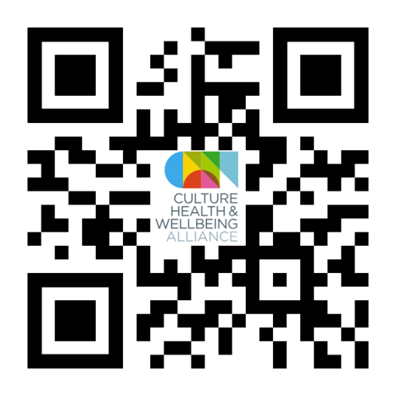

We welcome your feedback. Please scan the QR code to send any comments or suggestions

