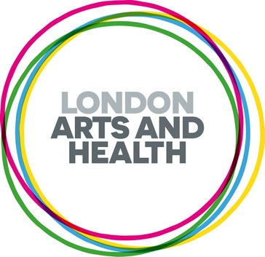
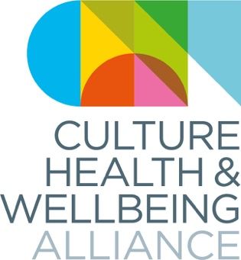

'Reclaiming Narratives' Pitches for Black History Month 2024
Culture, Health and Wellbeing Alliance (CHWA) and London Arts and Health (LAH) are pleased to be collaborating on a paid callout for ethnically diverse creative health artists/practitioners for Black History Month 2024. The theme for this year is ‘Reclaiming Narratives,’ and we are specifically looking for work that responds to this, and are inviting people to interpret this theme in a way that speaks to them. Selected pieces will be featured through the CHWA bulletin and LAH newsletter, website and social media channels throughout October 2024. Each selected piece will receive a fee of £150
Prior to completing this form, please read or listen to the full call out brief on our website.
Please note we invite people who have personal or professional experience in relation to this theme. Please respect this held space and do not apply if you don’t fit this criteria.

Please get in touch if we can support you in the process of applying or if you have any other questions at fiona@culturehealthandwellbeing.org.uk (we aim to get back to you within a week of sending an email).
Deadline: Monday 7th September 10am

Full Name
Gender
Preferred Pronouns
Email Address
What in the UK are you based?
Please pitch us your idea below and how it explores the theme of 'Reclaiming Narratives' (max 150 words)

Please note pitches must be pertaining to creative health and respond in some way to the theme of 'Reclaiming Narratives. Creative health can be any creative approaches and activities which have benefits for our health and wellbeing.'
Which best describes your idea (please pick one) | Creative Reflection  Example of practice  Artput from a previous project  Essay or blog
Please use this space to add any additional information you might want to share with us

eg. website, online portfolio, social media, image, video or audio, jpg, youtube

Please tell us your personal or professional interest in submitting for this callout/contributing on this theme

Thank you for taking the time to apply to this call out. Please return this form, along with a copy of your CV, to fiona@culturehealthandwellbeing.org.uk by Monday 7th September at 10am.

If you feel comfortable doing so, please fill our EDI questionnaire by following the link below. This helps us to understand more about and improve equity in creative health.

https://forms.gle/N1h7FXPpmEKCZ1eb6

