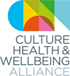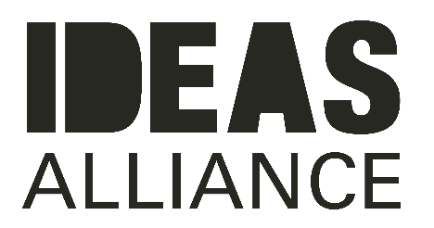

**COLLECTIVE POWER AWARD Application Form**

| Name |
| --- |
| Email |
| Contact Number |
| Project Name |
| Project website or web presence: |
| Where is/was the project based? |
| When did the project start and end (or is it ongoing)? |
| Your relationship to the project |
| Please list all partners/collaborators/instigators |
| Please list any funders for this project |
| **The Project**  General project description (150 words max) |
| What instigated this work, and how does it creatively respond to health and wellbeing? (150 words) |
| How does this project represent collective power, and how is it a good example of co-production? (150 words) |
| How did you embed lived experience in the project? (150 words max) |
| **Impact**  What have been its impacts so far? Please give us any stats associated (evaluation statistics, numbers taking part etc.) if you have them, and/or share any stories, quotes or case studies (200 words max) |
| **Other**  Is there anything else you want to tell us about the project/people involved? (200 words max) |
| Please add a maximum of three supporting links to any images/recordings/blogs/evaluations/films associated with the project you would like to share |

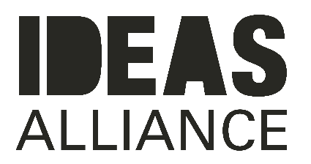

[Ideas Alliance](https://ideas-alliance.org.uk/) is an organisation that bridges stories with strategy by collaborating with people, organisations and places through commissioning, co-production and co-design. They have expertise in collaborative commissioning approaches, strategy development, service re-design and alliancing and work hand in hand with people as they rethink the role of citizens in the design and delivery of the public sector.

Since our inception in 2017, we have engaged with over 6,500 people through different projects with organisations across the country and we have published over 300 articles via the [Ideas Hub](https://ideas-alliance.org.uk/ideashub/), our online space for publishing case studies, interviews, blogs and reports about people getting on and making things happen.

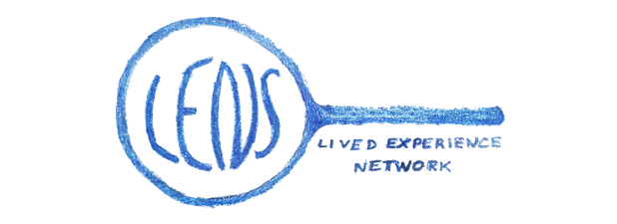

[The LENs](https://www.culturehealthandwellbeing.org.uk/get-involved/lens) is a network of people who believe in the benefits of creative and cultural engagement to individual and collective wellbeing.

By working in partnership and acting as a critical friend, The LENs will champion access to creative and cultural opportunities for all.

The LENs will work to ensure that the voices of those with lived experience remain at the heart of the arts, health and wellbeing movement.