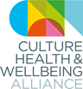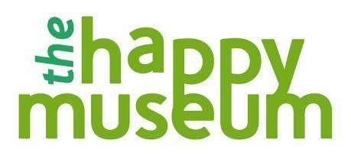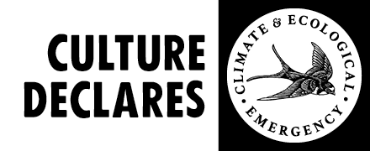

**CLIMATE AWARD**

**Application Form**

**Applications will be assessed in line with CHWA’s Creative Health Quality Framework Quality Principles. You can see an explanation of the quality principles below, or read the** [**full framework on our website.**](https://www.culturehealthandwellbeing.org.uk/sites/default/files/Creative%20Health%20Quality%20Framework.pdf)

|  |
| --- |
| Name |
| Email |
| Contact Number |
| Project Name |
| Project website or online links |
| Where is/was the project based |
| When did the project start and end (or is it ongoing)? |
| Your relationship to the project *eg. Freelancer/organisation/staff member* |
| Project Partners/Funders |
| **The Project**  General project description (150 words max) |
| We are interested in work that joins the dots between health and wellbeing, climate breakdown or inequality, and creativity/culture. How does your work use creativity/culture to enable the health and wellbeing of people, place and planet, and how does it acknowledge the interconnectedness of people/planetary health? (200 words) |
| In what wayshave you involved people with relevant lived experiences of environmental challenges and climate impacts? For example this may include, communities who experience poor air quality or fuel poverty alongside other multiple incidences of deprivation, or young people who climate distress or ‘eco-anxiety’ (150 words max) |
| **The Impact**  Feel free to describe impacts on health, behaviour, climate, and/or creativity. *(If you have any evaluation statistics, numbers taking part etc, please share them here, along with any stories, quotes or case studies)* (300 words max) |
| **Other**  Is there anything else you want to tell us about the project/people involved? (200 words max) |
| Please share a maximum of 3 supporting links to any images, recordings, blogs/evaluations or films associated with the project you would like to share. |
| **Have you declared?**  Culture Declares Emergency is a growing movement of people in arts and culture declaring a climate and ecological emergency. We pledge to tell truths, take action and seek justice. Arts and culture can lead in creating a regenerative future that protects the planet and sustains everyone, everywhere, please explore our resources and join the movement by making a [declaration](https://www.culturedeclares.org/declare/) <https://www.culturedeclares.org/declare/>  Yes (I have /I will)  No |