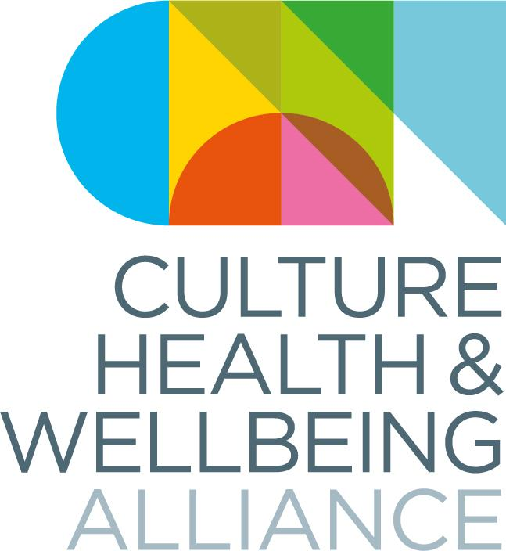

CHWA Awards 2025: Artist Commission

We would like to commission an artist based in Derby or Derbyshire to create the bespoke physical awards for the winners of the CHWA Awards 2022.

We are looking for an artist to respond creatively to each of the award categories (Collective Power, Practising Well and Healthy People and Planet), creating 3 new artworks that reflect the themes and celebrate the creativity, curiosity and commitment of people working in the creative health sector.

We are particularly interested in hearing from underrepresented artists including those from the global majority and those identifying as D/deaf, disabled or neurodivergent, and early-career artists.

For more information and to read the artist brief and listen to audio descriptions, please visit the CHWA website: <https://www.culturehealthandwellbeing.org.uk/get-involved/chwa-awards>

**Access is important to us**

We can accept applications in different formats, including audio and video. If you would prefer to apply in a format other than the application form, please use WeTransfer to send your application to [awards@culturehealthandwellbeing.org.uk](mailto:award@culturehealthandwellbeing.org.uk)

If you have any questions or need further support, please to contact us at [awards@culturehealthandwellbeing.org.uk](http://awards@culturehealthandwellbeing.org.uk)

**Important Dates**

Deadline for submission: **5pm Friday 10 January 2025**

Applicants informed of decision and selected artist commissioned: **Friday 31 January**

Delivery of video and images of end products: **Monday 7 April**

Awards Ceremony: Online - **Wednesday 23 April 2025 3-5pm**

|  |  |
| --- | --- |
| Name |  |
| Preferred Pronouns |  |
| Email |  |
| Address |  |
| Contact number (optional) |  |
| Website |  |
| Bio (up to 150 words or link to bio on site) * |  |
| Social media handles |  |
| How did you hear about this callout? | Word of mouth  CHWA Bulletin/Social Media  Twitter/Social Networks  ACE Jobs  Other: |
| Please share any initial ideas of what you would like to create. Describe potential artforms/styles, etc. Please note: rough sketches can be sent alongside this application (not necessary, but permitted). |  |
| Tell us why you would like to do this project? Why is it important/relevant to your practice or development as an artist? |  |

We are committed to building a focus on health and cultural inequalities into our structures and to ensuring our Board, employees, freelance contractors and stakeholder groups are representative in terms of socioeconomic background and all recognised protected characteristics as defined in the Equality Act 2010 (https://www.equalityhumanrights.com/en/equality-act/protected characteristics).

Please fill in this form to help us along the road to becoming a more equal alliance. Copy this link and open in a new window to complete: https://forms.gle/Pk3Xh6HtQ1K3RP696

Thank you for your time.