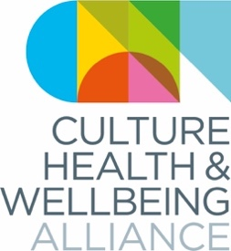
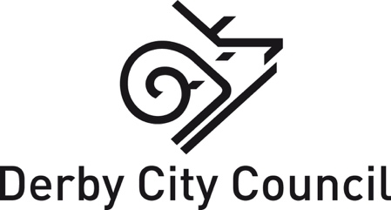

Bursaries for A Culture of Care

The annual conference of the Culture, Health & Wellbeing Alliance

19-20 March 2020, Derby Museums

In partnership with Arts Development at Derby City Council we are offering 10 free spaces to attend A Culture of Care to freelance creative practitioners and carers who live, or whose practice, is based in Derby.

Applications will be assessed by Arts Development at Derby City Council and the Culture, Health & Wellbeing Alliance.

We are particularly keen to ensure the bursaries are representative in relation to the protected characteristics recognised in the Equality Act 2010 as well as class and socioeconomic status.

Key dates
- Please email this form back to info@culturehealthandwellbeing.org.uk by 9am Monday 24 February.
- We will let you know whether you have been successful by the end of Friday 28 February.

Conference information

Our theme will be Care: care for one another (participants, practitioners, commissioners); care for the environment; and caring economies.
Confirmed panellists include Lord Howarth of Newport (president of the Culture, Health & Wellbeing Alliance), Esme Ward (Manchester Museums), Nicola Naismith (artist / researcher), Ian Solomon-Kawall (May Project Gardens), Gregor Henderson, Public Health England and Thanh Sinden (Museum Detox). We're thrilled that Baby People’s Melisma Choir will be performing on day 1 and Sinfonia Viva Carers' Choir on day 2, with more performances to come.
We will be publishing a timetable for the conference here.

To apply, please fill in the following:

1. Tell us about yourself. If you are a freelance creative practitioner, tell us about what kind of work you make. If you are a carer, tell us about your situation. (200 words max.)

2. Why do you want to attend A Culture of Care? How will it benefit your work as a carer or creative professional? (200 words max.)

3. Please give us up to three web links to your work, if relevant.

4. Please tell us which days you would like to attend the conference:

Day 1: Thursday 19 March
Day 2: Friday 20 March
Both days

Equality & Diversity information (optional)

Please fill in this form online.

