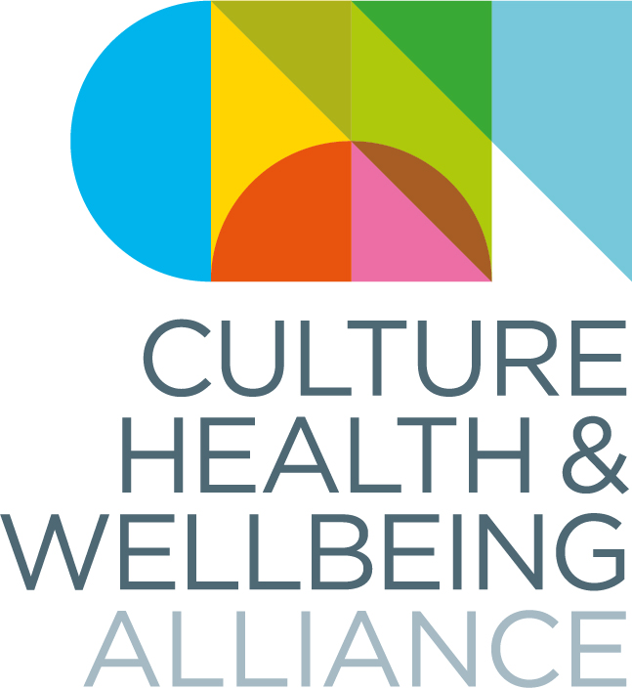
The Culture Health and Wellbeing Alliance (CHWA) is calling for images, photographs and videos that reflect the impact of art and culture on wellbeing for use on our website, in our marketing materials and for press/PR. The images, photographs and videos should be of high quality/resolution. All images, photographs and videos should be accompanied by a short description.

CONSENT FORM

Your consent
I hereby give my consent to the Culture, Health & Wellbeing Alliance (CHWA) to make use of the images/photographs/videos described below:

CHWA undertakes to ensure that the images/photographs/videos are credited as follows:
Please give us the actual wording you would like to accompany your image or video including any credits needed to the person who took the image/made the film.

I confirm that:
I hold the copyright for the images/photographs/videos above and/or that I have written permission to use them the copyright holders (please delete/cross out as appropriate): | Yes  No

I have written permission to use these images/photographs/videos from the people appearing in them | Yes  No

I consent for CHWA to use the images/photographs/videos for:

CHWA website | Yes  No
CHWA monthly bulletin | Yes  No
CHWA press/PR – this includes sending images to media outlets including, print, TV and online | Yes  No
Marketing materials – booklets, leaflets | Yes  No
CHWA conference | Yes  No
Social media | Yes  No

- If you change your mind about the use of photographs/images/videos, please contact CHWA
- Please note that CHWA cannot control other people’s use of the material once it has been published

Name _____________________________________

Organisation (if applicable) _____________________________________

Date _____________________________________

Signature _____________________________________

Twitter handle @___________________________________ (optional)

