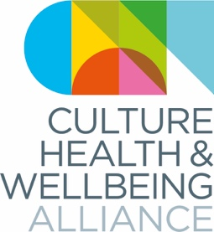
CULTURES OF HEALTH & WELLBEING
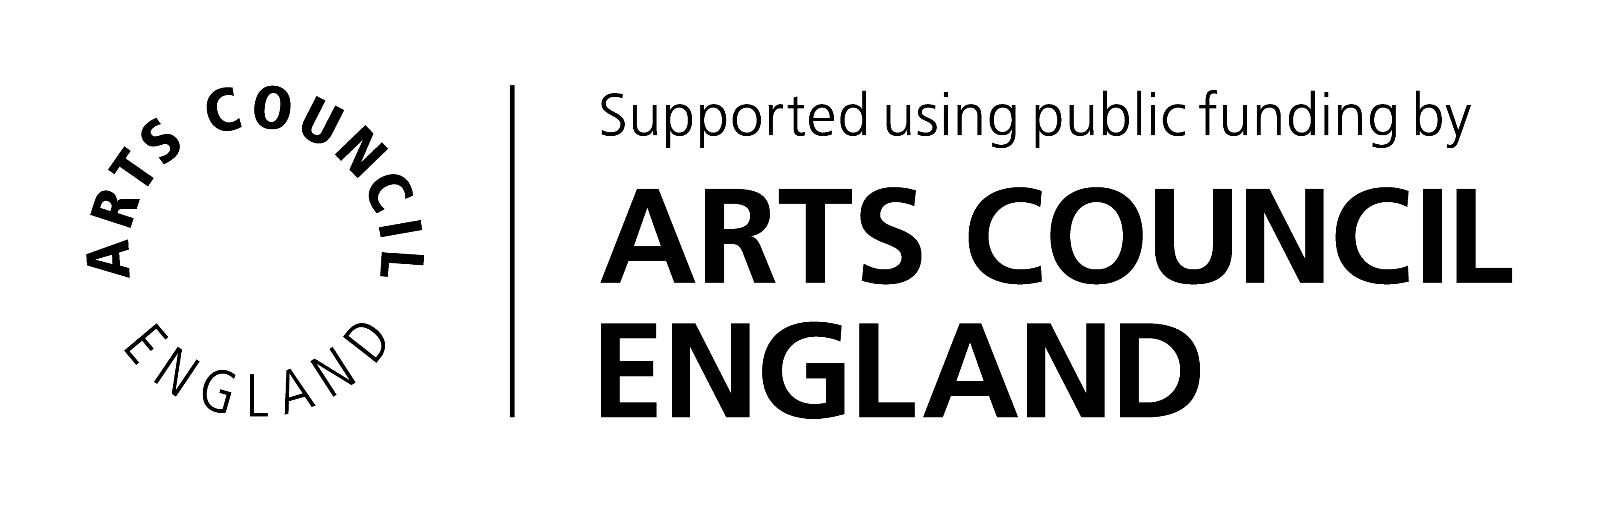
21-22 MARCH 2019 | GREAT NORTH MUSEUM: HANCOCK, NEWCASTLE

EVALUATION REPORT
This report is based on a number of sources: results from a surveymonkey survey to delegates, the written long sheet from the conference, vox pops taken by Michael McHugh (TWAM volunteer), and a recorded debrief straight after the conference with Hayley, Victoria and Fabric Lenny.

General points

There was positive feedback about the range and quality of speakers but also a clear demand for more space for Q&A and discussion (“too much sitting and being talked at” and “less is more” were amongst the comments). This generally worked best when the number of delegates in the room was closer to 100 than 200.

Feedback also suggests the following

Inclusivity/representation
- We need to do more work to ensure we are representative and inclusive in terms both of audience and participants
- More energy went into curating Day 1 which was arguably more representative in terms of speakers
- We need to consider how to evaluate this in a way that doesn’t rely on visibility
- A better consideration of countries outside England was needed

Curation
- We could be more choosy about provocations: limiting them to 3 per group and ensuring they are provocations and not presentations
- Provocations worked best in the morning in terms of energy
- A summing up session at the end of Day 1 would have given opportunities to a) air problems like e.g. voluntary question and b) set out a provocation to consider for Day 2
- Regional discussions would be useful; it would be good to ensure one regional champion per region min. is in attendance and can manage a regional breakout session
- Presenters should be cautioned against the over-use of arts terminology and academic language
- Positive feedback about mix in panels, (e.g.) having artists and health pros together
- More clarity about LENS – introduce earlier, and make patient voice more front-and-centre. Should have LENS person on every panel – and maybe a creative practitioner on every panel too.
- Positive feedback on Fabric Lenny and it feeling like a creative space – a couple of people wanted the digital drawing to link more to what was being said but the majority liked as it was

Managing people in the space
- Better planning for registration to accommodate numbers
- Make sure announcements are made (or on screen) about when to come back and where to go to avoid having to shunt people about from space to space
- Remember that it’s hard to make impromptu announcements
- Nominate a steering group person to be a go-to helper on each day
- Pre-book onto provocations and assign badges?

Planning notes
- Don’t put all the creative energy into day 1 (see diversity, above)
- Programme needs to be nailed earlier – keynotes December, provocations mid-Jan, conference mid-March
- More clarity about how to be on a panel, and what a provocation is

Technical issues
- Sound (tech. issues partly to do with size of venue – but presenters must be strongly encouraged to use lav. mics or headsets)
- Make sure files are compatible with small laptops and can be transferred across from macs to PCs rather than downloaded – and/or take mac adaptors and use our own equipment

Length
- It may have been too long by an hour or two
- Possibly start with an afternoon and run through the whole of the next day
- Back to back panels – maybe 1 or 2 too many
- They need to be managed more tightly with 5-mins max and signs to keep it to time

Volunteers
- We were completely dependent on the TWAM volunteers to make the conference work – how can we ensure similar support next time?
- Could/should volus be identified more clearly?
- Would whatsapp have helped communicate with volunteers?

Proposed alternatives
Our proposal is to limit the number of delegates to 150, and curate and theme the conference more tightly, allowing for greater space for discussion both plenary and in breakouts.

DAY 1 (afternoon)
- Lunch
- Keynote & Opening discussion
- Provocations

DAY 2 (full day)
- Keynote
- Regional conversations
- 2 panels max

We are investigating more interesting ways of using digital technology to stimulate discussion.

