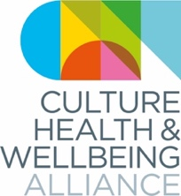
Equality, Diversity and Representation in CHWA’s board/staff and main stakeholder groups, as at 10 Sept 2020

Overall
This has been an important means of understanding the diversity of the stakeholder groups beyond what’s immediately visible. In relation to disability in particular, two of CHWA’s groups are more representative than I would have anticipated; and in relation to class, CHWA is closer to the national picture than I had anticipated. It’s worth noting that barring the Board/staff group, the stats for CHWA are not complete – 13/40 SAMs, 19/40 regional champions and 67/4971 members completed the form.

Disability
Slightly under-represented in membership (16.4% versus 21% of population), over-represented in regional champions (30.8% versus 21%). No representation in Board, staff and SAMs. It’s worth noting though that there is some ambiguity about categorisation here in relation to chronic heath/mental health/learning difficulties: although people have not declared themselves as having a disability in the SAMs and Board/staff groups, some nonetheless describe a long-term health conditions or learning difficulties.

Ethnicity
Black people are under-represented in the membership (1.4% of membership versus 3.3% nationally) and have no representation in the Board/staff, SAMs and regional champions groups. There is no representation of people of gypsy/traveller backgrounds (1% nationally). People of mixed race (2.2% nationally) are under-represented except in the membership. People of Asian descent (7% nationally) are under-represented in the membership and regional champions, but not the SAMs and Board/staff.

Gender
Women are dramatically over-represented in every group except the SAMs, where the gender balance is closer to the national picture (this is perhaps unsurprising given that the SAMs are generally senior roles in national organisations).

Sexuality
Overall CHWA is far more diverse in terms of declared sexuality than the general population.

Age
Younger people (<25) are under-represented across all stakeholder groups. Older people (65+) are under-represented in the Board/staff, and arguably also the SAMs and regional champions, although this is clearly impacted by retirement age.

Religion
There is a lower proportion of people declaring themselves to be Christian across all stakeholder groups than in the country as a whole; Hindus and Muslims also under-represented. CHWA generally has a higher proportion than the national figures for people with no religion, or atheist.

Class
The groups generally skew slightly more towards middle than working class than the national picture – averaging 56% middle class to 39% working class, where the national picture is broadly the reverse: 60% working class, 40% middle class. (It should be noted that this is an entirely subjective categorisation.)

In terms of schooling, it’s interesting to note that independent schools are significantly more represented in the SAMs (senior managerial positions in national organisations) than other groups. This sits alongside the different gender ratios in SAMs from the other groups – closer to national average.

Caring responsibilities
No population data yet sourced.

Regional distribution
Barring the SAMs, all groups are broadly distributed across all the regions of England. Yorks & Humber is the largest group represented in the member respondents. The SAMs, however, are predominantly based in London (over 50%) with smaller proportions in the West Mids, East, North East and South East.

Pink = suggested key issues of representation/divergence from national figs

Summary (%)

Category | Board & staff  Based on total numbers | SAMs  13 responses of 40 | Regional champions  13 responses of 19 | CHWA members  67 responses, 4971 members | National figs
Age |  |  |  |  | 2011 census
16-24 | 0 | 0 | 0 | 0 | ?
25-34 | 12.5 | 15.4 | 0 | 20.9 | ?
35-44 | 62.5 | 38.5 | 38.5 | 22.4 | ?
45-54 | 25 | 30.8 | 38.5 | 35.8 | ?
55-64 | – | 7.7 | 15.4 | 10.4 | ?
65+ | – | 0 | 7.7 | 10.4 | 16
Prefer not to say | – | 7.7 | – | – | ?
Ethnicity |  |  |  |  | 2011 census
Asian | 25 | 7.7 | 0 | 3 | 7
Black | 0 | 0 | 0 | 1.4 | 3.3
Mixed | 0 | 0 | 0 | 3 | 2.2
Gypsy/traveller | 0 | 0 | 0 | 0 | 1
White | 75 | 92.3 | 100 | 92.6 | 87
Other/prefer not to say | 0 | 0 | 0 | 0 | –
Gender |  |  |  |  | 2011 census
Women | 87.5 | 61.5 | 92.3 | 79.1 | 50.9
Men | 12.5 | 38.5 | 7.7 | 19.4 | 49.1
Genderfluid | 0 |  | 0 | 1.5 | –
Nonbinary | 0 |  | 0 | 0 | –
Trans | 0 |  | 0 | 0 | –
Prefer not to say | 0 |  | 0 | 0 | –
Sexuality |  |  |  |  | Experimental statistics on sexual orientation in the UK in 2018 (ONS)
Straight | 87.5 | 69.2 | 69.2 | 58.2 | 94.6
Bisexual | 12.5 | 7.7 | 23.1 | 17.9 | 0.9
Gay man | 0 | 0 | 0 | 7.5 | Gay or lesbian: 1.4%  NB Stonewall estimate 5-7%
Gay woman | 0 | 0 | 0 | 3
Queer | 0 | 7.7 | 0 | 7.5
Polysexual | 0 | 0 | 0 | 1.5
Prefer not to say | 0 | 0 | 7.7 | 4.5
Other | – | 15.1% Asexual | pansexual | – | –
Relationships |  |  |  |  | 2011 census
Married | 75 | 46.2 | 46.2 | 38.8 | 46.5
Single | 12.5 | 38.5 | 15.4 | 23.9 | 34.7
Divorced/formerly same-sex civil partnership | – | 0 | 0 | 7.5 | 8.8
Widowed/surviving partner as above | – | 0 | 7.7 | 1.5 | 7.0
Separated | – | 0 | 0 | 6 | 2.7
Registered same-sex civil partnership | – | 0 | 7.7 | Now included in “married” category above | 0.2
Cohabiting long-term |  | 7.7 | 21.2 | 18 | 0
Other |  | 7.7 (engaged) | 21.2 | 0 | 0
Prefer not to say | 12.5 | 0 | 0 | 4.5 | –
Religion |  |  |  |  | ONS for England & Wales (2018 figs)
No religion | 62.5 | 61.5 | 69.2 | 59.7 | 42.1  NB British Social Attitudes survey has this at 52% in 2018
Atheist | 12.5 | 15.4 | 15.4 | 4.5 | Category not given
Agnostic | 25 | 0 | 0 | 6 | Category not given
Christian | 0 | 15.4 | 0 | 13.4 | 47.1  NB British Social Attitudes survey has this at 38% in 2018
Buddhist | 12.5 | 0 | 7.7 | 0 | 1.0
Hindu | 0 | 0 | 0 | 0 | 2.4
Jewish | 0 | 0 | 0 | 1.5 | 1.1
Muslim | 0 | 0 | 0 | 0 | 6.3
Sikh | 0 | 0 | 0 | 0 | 1.2
Pagan | 0 | 0 | 0 | 3 | Category not given
Other | 0 | 7.7 | 7.7 | 6 | 2.3
Prefer not to say | 0 | 7.7 | 0 | 9 | Category not given
Do you consider yourself to be disabled? |  |  |  |  | Family Assets survey 2018/19
Yes | 0 (*see below) | 0 (*see below) | 30.8 | 16.4 | 21
No | 100 | 100 | 69.2 | 83.6 | 79
If yes… |  |  | …of the above 30.8% | …of the above 16.4% | …of the above 21%
A longstanding illness or health condi… | 0 | 7.7 | 25 | 33.3 | Data to be sourced
A mental health difficulty such as depression | 0 | 7.7 | 0 | 66.7 | 27
A physical impairment or mobility issue… | 0 | 0 | 0 | 6.7 | 48 NB categories differ so this may not be equivalent
A social/communication impairment such as… | 0 | 0 | 0 | 6.7 | Data to be sourced
A specific learning difficulty such as … | *12.5 | 0 | 0 | 20 | Data to be sourced
Blind or have a visual impairment… | 0 | 0 | 0 | 6.7 | Data to be sourced
D/deaf or have a hearing impairment | 0 | 0 | 0 | 0 | Data to be sourced
Prefer not to say | 0 | 7.7 | 25 | 6.7 | Data to be sourced
Self-described, or Other | 0 | 0 | 50 (multiple myeloma | Parkinson’s) | 6.7 autism and sensory processing difficulties, 6.7 chronic autoimmune disease | 18
Socioeconomic background |  |  |  |  | British Social Attitudes Survey 2015 (National Centre for Social Research)
Working Class | 37.5 | 38.5 | 38.5 | 43.3 | 60
Middle Class | 62.5 | 61.5 | 46.2 | 55.2 | 40
Upper Class | 0 | 0 | 0 | 0 | Category not referred to in BSA survey results
Prefer not to say | 0 | 0 | 0 | 4.5
Other | 1 person added “benefits class” | 0 | “I don’t know what we base class definition on” | “Mix of working and middle class” | 0
What type of school did you attend between the ages of 11 and 16? |  |  |  |  | Data to be sourced
State-run or state funded school-selective on academic, faith or other grounds | 14.3 | 15.4 | 23.1 | 22.4
State-run or state funded school- non selective | 57.1 | 46.2 | 61.5 | 65.7
Independent or fee-paying school- bursary | 14.3 | 15.4 | 7.7 | 3
Independent or fee-paying school- no bursary | 0 | 23.1 | 7.7 | 4.5
Attended school outside of the UK | 14.3 | 0 | 0 | 9
Other | 0 | 7.7 (independent school paid for by state) | 0 | 0
Don't know | 0 | 0 | 0 | 0
Prefer not to say | 0 | 0 | 0 | 0
If you finished school after 1980, were you eligible for Free Meals School at any point during your school years? |  |  |  |  | Data to be sourced
Yes | 25 | 7.7 | 16.7 | 12.3
No | 62.5 | 69.2 | 75 | 53.8
N/A | 0 | 23.1 | 8.3 | 29.2
Prefer not to say | 0 | 0 | 0 | 4.6
What is the highest level of qualifications achieved by either of your parent(s) or guardian (s) |  |  |  |  | Data to be sourced
At least one has a degree level qualification | 62.5 | 46.2 | 46.2 | 53
Qualifications below degree level | 25 | 30.8 | 38.5 | 28.8
No formal qualifications | 12.5 | 23.1 | 15.4 | 15.2
Don’t know | 0 | 0 | 0 | 1.5
Prefer not to say | 0 | 0 | 0 | 1.5
What are your caring responsibilities? (please tick all that apply) |  |  |  |  | Data to be sourced
Primary carer of a child or children under 16yrs old | 37.5 | 23.1 | 30.8 | 20.9
Primary carer of a disabled child or children | 0 | 0 | 7.7 | 3
Primary carer or assistant for a disabled adult (16 years and over) | 0 | 0 | 7.7 | 3
Primary carer or assistant for an older person or people (65 years and over) | 0 | 0 | 0 | 6
Secondary carer (another person carries out main caring role) | 25 | 0 | 0 | 13.4
None | 37.5 | 76.9 | 61.5 | 62.7
Prefer not to say | 0 | 0 | 0 | 0

Geographic spread (not including regional champions)

Members
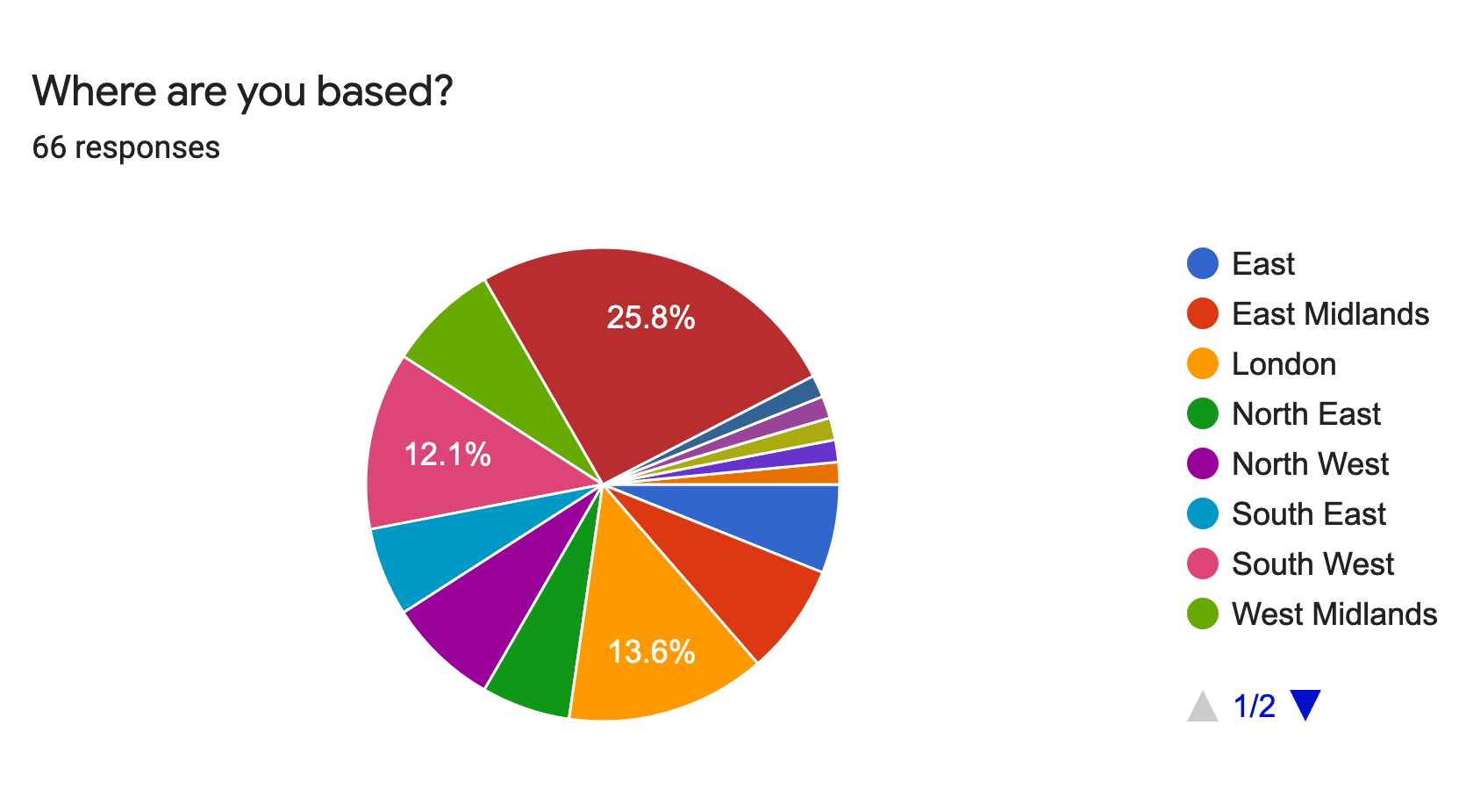

Strategic Alliance Members
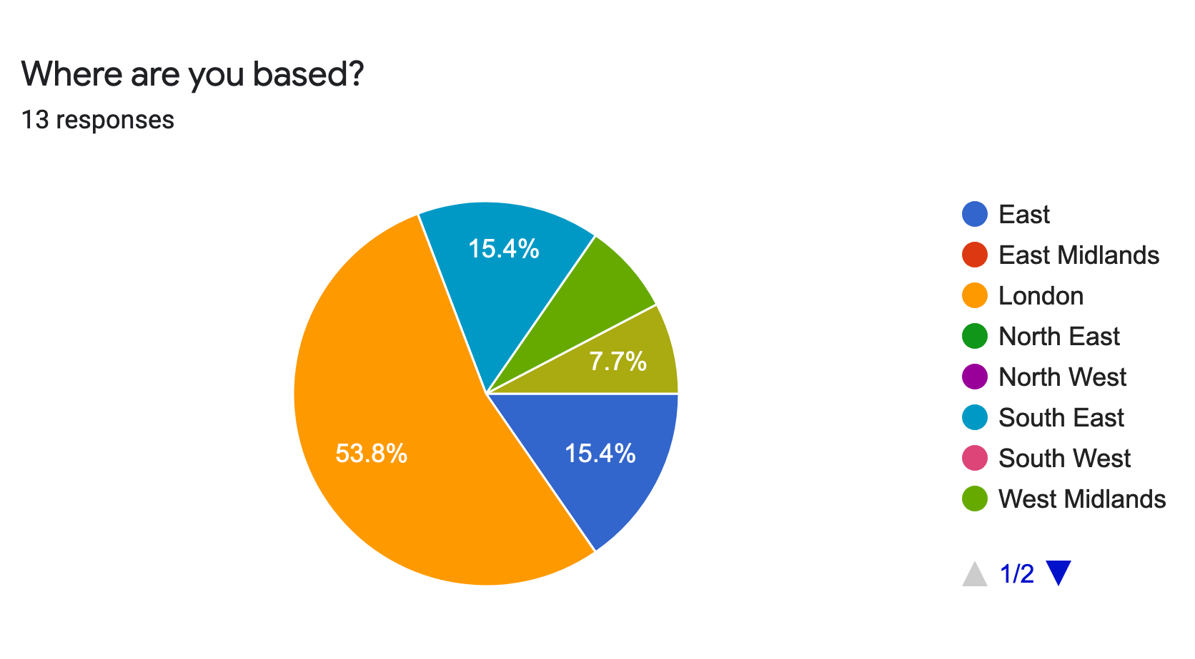
Board/staff
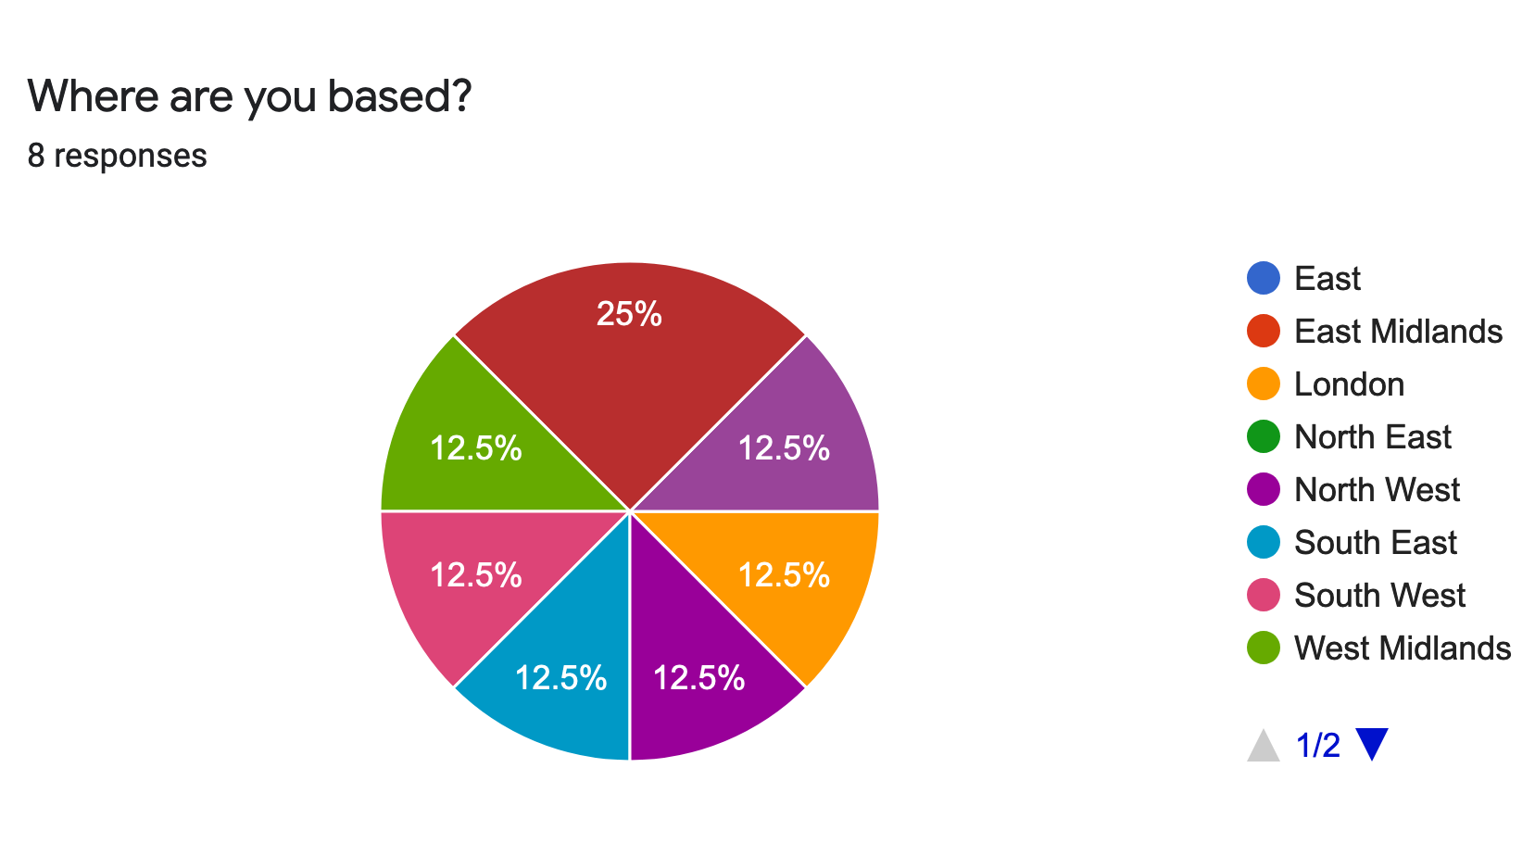

https://www.ons.gov.uk/peoplepopulationandcommunity/culturalidentity/religion/datasets/religioneducationandworkinenglandandwales
https://assets.publishing.service.gov.uk/government/uploads/system/uploads/attachment_data/file/874507/family-resources-survey-2018-19.pdf

