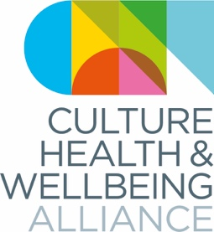
Policy & Procedures

Reserves and Investment

Introduction
The responsibility for ensuring this policy is implemented rests ultimately with the Board of Directors. However, members of staff are responsible for the implementation of the policy and monitoring it on a day-to-day basis and reporting on its operation to the Board.

Reserves
The Directors are mindful of the need to retain general unrestricted funds whenever possible. Reserves will be available for future unexpected needs, such as meeting unfunded project overspends, or to pursue an opportunity in line with the charity’s mission. The Directors are also satisfied that the charity’s assets are available and adequate to fulfil its obligations.

The aim of the Directors is to maintain a level of free, unrestricted reserves (of or around 3-months average core expenditure) that will enable CHWA to operate from a financial perspective with certainty and flexibility.

Investment
The Directors will invest funds that are surplus to the immediate needs of the charity in investments that generate reasonable rates of return whilst minimising the risk of loss. Investment gains and losses are taken through the Statement of Financial Activities to unrestricted reserves.

Any investment will be governed by the following ethical framework, which echoes our fundraising policy:

- The organisations invested in do not act in conflict with CHWA’s values
- The Executive Director and Board of Directors are satisfied that no adverse publicity will result from accepting such support

Avoidance Criteria
CHWA will not invest in companies directly involved in activities that run contrary to its overall charitable objectives, vision or charitable aims. In particular it will not invest in organisations involved with any of the following activities: Animal testing; genetic engineering; human rights abuses; intensive farming; manufacture of environmentally hazardous products or chemicals; military contracts; fossil fuel industries including mining; nuclear power; low-and-middle-income countries’ debt and/or marketing; the manufacture of tobacco; water pollution; and food industries involved with products known to be damaging to health, including alcohol, high-sugar and highly processed foods or drinks.

Acceptance Criteria
When deciding whether to invest, the Executive Director and Board of Directors have a duty not to compromise CHWA’s ethical position, harm its reputation or put future funding at risk. CHWA complies with all relevant legislation, including money laundering rules, the Bribery Act and Charity Commission guidance, including terrorism and political activity. CHWA will therefore not invest in organisations that:
- Are known to be associated with criminal sources and/or illegal activity
- Would lead to a possible decline in support for CHWA, and so risk a fall in the resources available to fund its work or damage its longer-term fundraising prospects
- Would otherwise impact adversely on CHWA’s reputation
- Act in a way inconsistent with Government policy

7. Review and Maintenance of Policy
CHWA will undertake to review this policy, its implementation and effectiveness annually. The views of all employees and volunteers shall be sought where necessary and reflected in the review process.

Any new legislation or developments in existing legislation will be considered as and when required and the policy will be updated to reflect these developments.

This policy was approved and agreed by the Board of Directors on the date shown below.

Signed: 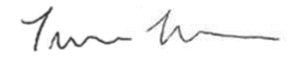

Name (please print): Trishna Nath

Position: Trustee Treasurer

Date: 06/05/2022

Review dates: one year after the above | annually thereafter

Organisation name: Culture, Health & Wellbeing Alliance CIC

Company Number: 12359172

